**CSIS 2200:**

**Slide 01: Information System an Overview**

**Computer literacy:**

Skill in using productivity software, as well as having a basic knowledge of hardware and software, the internet, and collaboration tools and technologies.

**Information Literacy:**

Understanding the role of information in generating and using business intelligence (BI). Provides historical, current and predictive views of business operations and environments and gives organizations a competitive advantage in the marketplace.

**Transaction-Processing Systems (TPS):**

* Focus on data collection and processing.
* Used for cost reduction.
* Applied to structured task.
* Require minimal human involvement when automated.

**Management Information System (MIS):**

* Organized integration of hardware and software technologies, data, processes, and human elements.
* Designed to produced timely, integrated, relevant, accurate, and useful information for decision-making.
* Designing tasks
  + Define the system’s objectives
  + Collect and analyze data
  + Provide information in a useful format for decision-making purposes.
* MIS applications
  + Used in both private and public sectors.

**Components of an Information System:**

*Data | Database | Process | Information*

1. Data:
   1. Considered the input of a system.
   2. Sources of data:
      1. Internal: records.
      2. External: customers, suppliers, government agencies, labor…
   3. Has a time orientation:
      1. Past data: performance reports.
      2. Current data: operational reports.
   4. Can be collected in different forms:
      1. Disaggregated data: helps analyze sales by product, territory, or salesperson.
      2. Aggregated data: useful for reporting overall performance during a sales quarter.
2. Database:
   1. Collection of relevant data organized in a series of integrated files.
      1. Essential for the success of any information system.
   2. Database management System (DBMS)
      1. Used to create, organize, and manage databases
      2. Reduces personnel time needed to gather, process, and interpret data manually.
3. Process:
   1. Generates the most useful type of information for making decisions
      1. Transaction-processing reports.
      2. Models for decision analysis that can be built into the system or accessed from external sources.
4. Information:
   1. Consists of facts analyzed by the process component and is an output of an information system.
      1. Usefulness qualities
         1. Timelines
         2. Integration with other data and information
         3. Consistency and accuracy
         4. Relevance
   2. Needs to provide either a base for users to explore different options or insight into tasks.
   3. Usefulness is affected by the information system’s user interface.
      1. Graphical user interfaces (GUIs) are used because they are flexible and easy.
   4. Systems should produce information in different formats, including graphics, tables and exception reports.
      1. Increases likelihood of users understanding and being able to use the information.
   5. Users need to be able to make use of informal information when solving problems.

**Information technologies:**

* The internet.
* Computer networks.
* Database systems.
* Point-of-sale (POS) systems.
* Radio-frequency-identification (RFID)

**Importance of Information Systems:**

* Timely, relevant, and accurate information is a critical tool.
  + Enhance competitive position in the marketplace.
* Manage the four Ms of resources:
  + Manpower
  + Machinery
  + Materials
  + Money
* Personal Information System (PIS) or Human Resource Information System (HRIS)
  + Designed to provide information that helps decision makers in personnel carry out tasks effectively.
* Logistic Information System (LIS)
  + Designed to reduce the cost of transporting materials while maintaining safe and reliable delivery.
* Manufacturing information system (MIS)
  + Used to manage manufacturing resources.
  + Reduce manufacturing costs.
  + Increase product quality.
  + Improve inventory decisions.
* Financial information system (FIS)
  + Used to provide information to financial executives in a timely manner.
* Marketing information system (MKIS)
  + Used to improve marketing decisions.
  + Provides timely, accurate, and integrated information about the marketing mix.
  + Price, promotion, place and product.
* Marketing technology tools
  + Business, web, and mobile analytics
  + E-mail marketing
  + Search engine marketing
  + Mobile technologies
  + Marketing automation

**Using Information Technologies for a Competitive Advantage:**

* Michael Porter: Three strategies for successfully competing in the marketplace.
  + Overall cost leadership.
  + Differentiation.
  + Focus.
* Information systems
  + Help organizations reduce the cost of products and services.
  + Help bottom-line and top-line strategies.
  + Use enterprise systems to create an efficient and effective link between suppliers and consumers.
* Differentiation strategies
  + Making products and services different from competitors.
* Focus strategies
  + Focusing on specific market segments to achieve a cost or differentiation advantage.

**Porter’s Five Forces Model: Understanding the Business Environment**

* Analyzes a firm’s position in the marketplace and how information systems can make it more competitive.
  + Five forces
    - Buyer power.
      * **High** when customers have **many** choices.
      * **Low** when customers have **few** choices.
    - Supplier power.
      * **High** when customers have **fewer** options
      * **Low** when customers have **more** options
    - Threat of substitute products or services.
      * **High** when **many alternatives** to an organization’s products and services are available.
    - Threat of new entrants.
      * **Low** when duplicating a company’s product or service is difficult.
      * **Focus** strategies are used to ensure that the threat remains low.
    - Rivalry among existing competitors.
      * **High** when competitors occupy the same marketplace position.
      * **Low** when there are few competitors.

This image depicts the five forces model. There is rectangular box positioned at the center of the image, and four boxes have been positioned around this box. The box on the left is labeled suppliers, the box on the right is labeled buyers, the box at the top is labeled potential entrants, and the box at the bottom is labeled substitutes.  
The box at the center contains two points that read industry competitors and rivalry among existing competitors. A U-shaped arrow has been positioned between these points. The arrowhead points at the first point. 
An arrow arises from the right side of the box labeled suppliers that is positioned on the left and points at the box at the center of the image. This arrow is labeled bargaining power of suppliers. 
An arrow arises from the left side of the box labeled buyers that is positioned on the right and points at the box at the center of the image. This arrow is labeled bargaining power of buyers. 
An arrow arises from the bottom of the box labeled potential errants that is positioned at the top and points at the box at the center of the image. This arrow is labeled threats of new entrants. 
An arrow arises from the top of the box labeled substitutes that is positioned at the bottom and points at the box at the center of the image. This arrow is labeled threat of substitute products or services.  

**The IT Job Market**

* Operations and help desk.
* Programming.
* Systems design.
* Web design and web hosting.
* Network design and maintenance.
* Database design and maintenance.
* Robotics and artificial intelligence.
* Chief of Technology Officer (CTO) / Chief of Information Officer (CIO)
  + Oversees long-range planning and monitors new developments that can affects a company’s success.
* Chief Privacy Officer (CPO)
  + Responsible for managing risks and business impacts of privacy laws and policies.
* Manager of information systems services
  + Responsible for managing hardware, software, and personnel in the information systems department.
* Systems analyst
  + Responsible for the design and implementation of information systems.
  + Should have a sound understanding of business systems and functional areas within a business organization.
* Network administrator
  + Oversees a company’s internal and external network systems.
  + Provides network and cybersecurity.
* Database administrator (DBA)
  + Responsible for database design and implementation.
  + Required to have knowledge and understanding of data warehouses and data-mining tools.
* Computer programmer
  + Writes programs or software segments that allow the information system to perform a specific task.
* Webmaster
  + Designs and maintain the organization’s web site.
  + Have been in high demand owing to the popularity of e-commerce applications.

**Outlook for the Future**

* Hardware and software costs will decline
* Artificial intelligence and related technologies will improve and expand.
* Computer literacy and networking technology will improve.
* Personal computer will improve in power and quality.
* Internet growth will continue.
* Computer criminals will become more sophisticated.
* Protecting personal information will become more difficult.
* Ubiquitous computing and the Internet of Things (IoT).
* 3D printing, pervasive analytics, context aware computing, smart machines and devices, and cloud computing.
* Software defined applications and infrastructures.
* Security.
* Increased applications of augmented and virtual reality.

Check computer: Core, ram, cache, # of usb port

**Slide 02: Computers: The Machines Behind Computing**

**Defining a Computer:**

* A computer is a machine that:
  + Accept data as input.
  + Processes data without human intervention using stored instructions.
  + Outputs information.
* Instructions:
  + Step-by-step directions for performing a specific task.
  + Written in a language the computer can understand.
* Garbage in, garbage out (GIGO):
  + If the input data is erroneous, the information provided by the computer is also erroneous.
* Writing a computer program:
  + Identify what needs to be done.
  + Write the algorithm to achieve the goal.
  + Select a programming language for it. (depends on the problem and the computer)
* A program is also called a source code (a sequence of 0’s and 1’s).

**Components of a Computer System:**

* Hardware: physical devices such as keyboard, monitors, processing units.
* Software: programs written in computer languages.
* Central Processing Unit (CPU): the heart of the computer
  + Arithmetic Logic Unit (ALU): perform the arithmetic operations.
  + Control Unit: tells the computer what to do such as instructing the computer which device to read or send output to.
* Computers can have a single processor or multiple ones (two or more CPUs).



* Bus: link between devices connected to the computer.
  + Parallel or serial.
  + Internal (local) or external.
* Disk drive: peripheral device for recording, storing, and retrieving information.
* CPU case: enclosure containing the computers main components (computer chassis or tower).
* Motherboard: main circuit board containing connectors for attaching additional boards.

**Hardware Generations:**

**The Power of Computers:**

* Speed.
  + Measured by the number of instructions executed per fractions of a second:
    - Millisecond: 1/1,000
    - Microsecond: 1/1,000,000
    - Nanosecond: 1/1,000,000,000
    - Picosecond: 1/1,000,000,000,000
* Accuracy.
* Storage and retrieval capabilities.
  + Save data in computer memory.
  + Access data from memory.
  + Data stored in bits.
  + American Standard Code for Information Interchange (ASCII).
    - Defines up to 128 characters.

**Computer Operations:**

* Computer functions:
  + Three basics tasks:
    - Arithmetic operations.
    - Logical operations.
    - Storage and retrieval operations.
  + Input, Output and Memory
  + Main Memory:
    - Volatile and nonvolatile.
    - Random Access Memory (RAM).
    - Cache RAM: stores recently accessed memory.
      * Resides on the processor.
      * Made of silicon.
    - ROM (Read-only Memory).
      * Nonvolatile memory.
      * Data cannot be written to it.
      * Includes BIOS information and the computer system’s clock.
      * Programable read-only memory (PROM).
      * Erasable Programable read-only memory (EPROM).
  + Secondary Memory:
    - Magnetic disks.
      * Made of Mylar or metal.
      * Used for random-access processing.
    - Magnetic tape:
      * Made of a plastic material.
      * Stores data sequentially.
    - Optical disks:
      * Use lasers beams to access and store data.
      * CD-ROMs, WORM discs, and DVDs.
      * Include hard disks, USB flash drives, and memory cards.
    - Redundant Array of Independent Disks (RAID):
      * Collection of disk drives used for fault tolerance and improved performance.
      * Found in large network systems.
    - Cloud storage:
      * Involves multiple virtual servers that are hosted by third parties.

* Storage Area Network:
  + Dedicated high-speed network consisting of both hardware and software.
  + Connect and manage shared storage devices
  + Disk arrays, tape libraries, and optical storage devices.
* Network-Attached Storage (NAS)
  + Network-connected computer dedicated to provide file based data storage services to other network devices.

**Classes of Computer:**

* Based on cost, amount of memory, speed and sophistication.
* Subnotebooks and notebooks
* Personal and minicomputers
* Mainframes
* Supercomputers

**Server Platforms: An Overview**

* Server: computer and all the software for managing network resources and offering services to a network.
* Available server platforms: applications servers, database servers, disk servers, fax servers, file servers, mail servers, print servers, remote access servers (RAS), and web servers.

**What is a Software?**

* Programs that run a computer system.
* Classification:
  + System software: work in the background and takes care of tasks, such as deleting waste files.
  + Application software: performs specialized tasks.

**Operating System Software:**

* Set of programs controlling and managing computer hardware and software.
  + Provides an interface between a computer and the user.
  + Increases computer efficiency by helping users share computer resources and performing repetitive tasks for users.
  + Increases computer efficiency by helping users share computer resources and performing repetitive tasks for users.
* Consists of control programs to manage hardware and resources by performing:
  + Job management.
  + Resource allocation.
  + Data management
  + Communication
* Supervisor program (i.e., the Kernel)
  + Responsible for controlling all other programs in th OS.
* Application Software:
  + Commercial software or software developed in house; used t perform variety of tasks on a personal computer.
    - Word processing, spreadsheet, database, presentation and graphics.
    - Desktop publishing.
    - Financial planning and accounting.
    - Computer-aided design (CAD).
* Computer Languages:
  + Machine Language:
    - First generation of computer languages.
    - Consists of a series of 0s and 1s representing data or instructions.
    - Dependent on the machine.
    - Time-consuming to write a program.
  + Assembly language:
    - Second generation of computer languages.
    - Machine dependent and a higher-level language than machine language.
    - Uses a series of short codes, or mnemonics, to represent data or instructions.
  + High-level languages:
    - Third generation of computer languages.
    - Machine independent and self-documenting.
    - Used for web development and internet applications.
  + Fourth-generation languages (4GLs):
    - Commands are powerful and easy to learn.
    - Use macro codes that can take the place of several lines of programming.
  + Fifth-generation languages:
    - Used artificial intelligence technologies.
    - Knowledge-based systems, natural language processing (NLP), visual programming, and a graphical approach to programming.
    - Designed to facilitate natural conversations between an individual and the computer.

**Slide 03: Database Systems, Database Workers and Data Marts**

**Databases:**

* Database:
  + Collection of related data that is stored in a central location or in multiple locations.
* Data Hierarchy:
  + Structure and organization of data, which involves fields, records, and files.
* Database Management System (DBMS)
  + Software for creating, storing, maintaining, and accessing database files.
  + Makes using databases more efficient.

**Interaction between the User, DBMS, and Databases:**

This illustration depicts the interaction between the User, DBMS, and Database. 
A rectangular box has been positioned at the center of the illustration. This box is labeled D B M S.
A circle has been placed on the left side of the illustration. This circle is labeled user. An arrow arises from the right side of this circle and points at the box labeled D B M S. A rectangular box has been aligned on the top of this arrow, and it contains text that reads user makes a request for information. An arrow arises from the left side of the box labeled D B M S and points at the circle. A rectangular box has been aligned at the bottom of this arrow, and it contains text that reads D B M S returns information to the user. 
A cylinder has been placed on the right side of the illustration. This cylinder is labeled database. An arrow arises from the right side of the box labeled D B M S and points at the cylinder. A rectangular box has been aligned on the top of this arrow, and it contains text that reads D B M S searches the database. An arrow arises from the left side of the cylinder and points at the box labeled D B M S. A rectangular box has been aligned at the bottom of this arrow, and it contains text that reads D B M S retrieves the information. 

**Types of Databases:**

* Internal data:
  + Collected from within an organization.
  + Stored in the organization’s internal databases and can be used by functional information systems.
* External data:
  + Comes from a variety of sources.
  + Stored in a data warehouse.

**Methods for Accessing Files**

* Sequential access file structure:
  + Records in files are organized and processed in numerical or sequential order.
  + Records are organized based on a primary key (e.g., Social Security numbers or Account numbers).
  + Used for backup and archive files because they rarely need updating.
* Random Access File Structure
  + Records can be accessed in any order, regardless of their physical locations in storage media.
  + Fast and very effective when a small number of records need to be processed daily or weekly.
  + Records are stored on magnetic disks to achieve speed.
* Indexed Sequential Access Method (ISAM)
  + Records accessed sequentially or randomly, depending on the number accessed.

**Random access** is used for a **small amount of data**. While the **sequential access** is used for a **larger set of data**. Indexed sequential one uses an index structure with two parts: index value and a pointer to the disk location of the record matching the indexed value.

**Logical Database Design**

* Information is viewed in a database in two ways
  + Physical view: how data is stored on and retrieved from storage media.
  + Logical view: how information appears to users and how it can be organized and retrieved.
    - Depending on the user, there can be more than one logical view of data.
* Data model determines how data is created, represented, organized, and maintained
  + Data structure.
  + Operations.
  + Integrity rules.
* Hierarchical model:
  + Relationships between records form treelike structure.
  + Records are called nodes, and relationships between records are called branches.

This flowchart depicts an example of a hierarchical model. It is divided into four levels. The content against the second, third, and fourth levels reads siblings.
A box has been positioned at the top center of the flowchart, and this box is labeled supplier A. Three lines arise from the bottom of this box and lead downward to three different boxes, which have been positioned horizontally. All three boxes have been labeled product line. 
Two lines arise from the bottom of the first box labeled product line. These lines lead downward to two different boxes. The first box is labeled P1, and the second box is labeled P2. Two lines arise from the bottom of the box labeled P1 and lead downward to two boxes, which are labeled A and B. Four lines arise from the bottom of the box labeled P2 and leads downward to four boxes, which are labeled C, D, E, and F. 
Three lines arise from the bottom of the second box labeled product line. These lines lead downward to three different boxes. The first box is labeled P3, the second box is labeled P4, and the third box is labeled P5. Two lines arise from the bottom of the box labeled P3 and lead downward to two boxes, which are labeled G and H. Three lines arise from the bottom of the box labeled P4 and lead downward to three boxes, which are labeled I, J, and K. Three lines arise from the bottom of the box labeled P5 and lead downward to three boxes, which are labeled L, M, and N. 
Two lines arise from the bottom of the third box labeled product line. These lines lead downward to two different boxes. The first box is labeled P6, and the second box is labeled P7. Four lines arise from the bottom of the box labeled P6 and lead downward to four boxes, which are labeled O, P, Q, and R. Three lines arise from the bottom of the box labeled P7 and lead downward to three boxes, which are labeled S, T, and U. 

* Network model:
  + Similar to the hierarchical model but records are organized differently.
  + Each record can have multiple parent and child records.

This flowchart depicts the network model in the form of a flowchart. It is divided into three levels. The content against the first level reads customer number. The content against the second level reads invoice number. The content against the third level reads method of payment. 
Three boxes have been positioned horizontally at the top of the flowchart. These boxes are labeled 2000, 3000, and 9000.  A line arises from the box labeled 2000 and leads downward to a box labeled 111. Two lines arise from the box labeled 3000 and lead downward to two different boxes, which are labeled 222 and 333. Two lines arise from the box labeled 9000 and lead downward to two different boxes, which are labeled 444 and 555. 
Three lines arise from each of the boxes labeled 111, 333, and 444 and lead downward to a box that is labeled cash. Two lines arise from each of the boxes labeled 222 and 555 and lead downward to a box that is labeled credit. 

**The Relational Model**

* Uses a two-dimensional table of rows and columns of data:
  + Rows are records (i.e., tuples)
  + Columns are fields (i.e., attributes)
* Data dictionary:
  + Stores definitions, such as data types for fields, default values, and validation rules for data in each field.
* Primary key:
  + Uniquely identifies every record in a relational database.
* Foreign key:
  + Field in a relational table that matches the primary key column of another table.
  + Used to cross-reference tables.
* Normalization:
  + Used to improve database efficiency.
    - Eliminates redundant data.
    - Ensures only related data is stored in a table.
  + Goes through different stages, from the first normal form (1NF) to the fifth normal form (5NF).
* Operations:
  + Help retrieve data from tables.
  + Common operations: select, project, join, intersect, union, and difference.

**Components of a DBMS**

* DBMS software components:
  + Database engine
  + Data definition
  + Data manipulation
  + Application generation
  + Data administration
* Database engine:
  + Responsible for data storage, manipulation and retrieval.
  + Interacts with other components of the DBMS to convert logical requests from the users into their physical equivalents.
* Data definition:
  + Used to create and maintain the data dictionary and define database file structure.
  + Makes changes to a database’s structure.
* Data manipulation:
  + Used to add, delete, modify, and retrieve records from a database.
  + Uses a query language, such as Structured Query Language (SQL).
* Application Generation:
  + Designs elements of an application using a database.
  + Used by IT professionals and database administrators.
* Data Administration:
  + Used for tasks such as backup and recovery, security, and change management.
  + Used to determine who has permission to perform certain functions, summarized as create, read, update, and delete (CRUD)
* Database Administrators (DBAs)
  + Handle database design and management.

**Recent Trends in Database Design and Use**

* Data-driven web sites.
* Natural language processing.
* Distributed databases.
* Object-oriented databases.
* Advances in artificial intelligence.

**Data-Driven Web Sites**

* Acts as an interface to a database
  + Retrieves data and allows users to enter data in the database.
* Improves access to information:
  + Reduces support and overhead needed to maintain static web sites.
  + Gives users more current information from a variety of data sources.

**Distributed Databases**

* Distributed Database Management System (DDBMS)
  + Stores data on multiple servers throughout an organization.
  + Several advantages:
    - Design better reflects the firm’s structure.
    - Local data storage reduces response time.
    - Minimizes effects of computer failure.
    - Cost advantage.
    - Not limited by physical location of the data.
* Approaches to setting up a DDBMS:
  + Fragmentation: addresses how tables are divided among multiple locations.
  + Replication: each site stores a copy of the data in the organization’s database.
  + Allocation: combines fragmentation and replication.
* Object-Oriented Databases:
  + Data and their relationships are contained in a single object.
    - Object consists of attributes and methods that can be performed on the object’s data.
      * Encapsulation: grouping objects along with their attributes and methods into a class.
      * Inheritance: new objects can be created faster and more easily by entering new data in attributes.
  + Advantages of object-oriented database:
    - Supports more complex data management.
    - Handles storing and manipulating all types of multimedia as well as numbers and characters.

**Data Warehouses**

* Collection of data from a variety of sources.
  + Support decision-making applications.
  + Generate business intelligence.
* Called hypercubes because they can store multidimensional data.
* Characteristics of data in a warehouse
  + Subject oriented.
  + Comes from a variety of sources.
  + Categorized based on time.
  + Captures aggregated data.
  + Used for analytical purposes.

**Data Warehouses Configuration**

* Input:
  + Different data sources provide the input for a data warehouse to perform analyses and generate reports
    - External data sources, databases, and transaction files.
    - Enterprise resources planning (ERP) systems.
    - Customer relationship management (CRM) systems.

This image depicts the configuration of a data warehouse and highlights its components. Four cylinders have been positioned vertically, one below the other, on the left side of the image. From the top to the bottom, these boxes are labeled databases, transaction files, enterprise resource planning systems, and customer relationship management systems. Another cylinder has been positioned at the top of the image. This cylinder is labeled external data sources. 
Arrows arise from the right side of each of the four cylinders positioned on the left side and from the bottom of the cylinder positioned at the top of the image. These arrows point at a rectangular box positioned vertically at the center of the image. This box is labeled extraction, transforming, and loading. An arrow arises from the right side of the box at the center and leads to another long, vertically-positioned cylinder. This cylinder is labeled raw data, summary data, and metadata. 
Three arrows arise from the right side of the vertically-positioned, long cylinder. The first arrow points at content that reads O L A P analysis. The second arrow points at content that reads data-mining analysis. The third arrow points at content that reads decision-making reports.

* Extraction, Transformation, and Loading (ETL):
  + Processes used in a data warehouse.
    - Collecting data from a variety of sources.
    - Converting data into a format that can be used in transformation processing.
    - Loading data into the data warehouse.
* Storage:
  + Collected information is organized in a date warehouse as:
    - Raw data: information in its original form.
    - Summary data: gives users subtotals of various categories.
    - Metadata: information about data’s content, quality, condition, origin, and other characteristics.
* Output:
  + Data warehouses use the following to generate reports:
    - Online analytical processing (OLAP)
      * Uses multiple sources of information and provides multidimensional analysis.
      * Generates business intelligence.
    - Data mining analysis
      * Used to discover patterns and relationships.
  + Benefits of data warehouses:
    - Cross-reference segments of an organization’s operations for comparison.
    - Generate complex queries and reports faster than when using databases.
    - Generate reports efficiently using data from a variety of sources.
    - Find patterns and trends that cannot be found with databases.
    - Analyze large amounts of historical data quickly.
    - Assist management in a making well-informed business decisions.
    - Manage a high demand for information from many users with different needs and decision-making styles.

**Data Marts**

* Smaller version of a data warehouse used by a single department or function.
  + Advantages over warehouses:
    - Faster access to data owing to its smaller size.
    - Improved response time for users.
    - Easier to create because of its size and simplicity
    - Less expensive.
    - Effective targeting of users.
  + Disadvantages:
    - Limited scope.
    - Difficulty in consolidating information from different departments or functional areas.

**Business Analytics**

* Uses data and statistical methods.
  + Gains insight into the data.
  + Provides decision makers with information to act on.
* Methods:
  + Descriptive
  + Predictive
  + Prescriptive
  + Descriptive Analytics:
    - Reactive strategy
    - Reviews past events, analyzes the data, and provides a report indicating:
      * What happened in a given period of time?
      * How to prepare for the future.
  + Predictive analytics:
    - Proactive strategy
    - Prepares decision makers for future events
  + Prescriptive analytics
    - Recommends a course of action that decision makers should follow.
    - Shows the likely outcome of each decision.

**The Big Data Era**

* Voluminous data
  + Conventional computing methods are unable to efficiently process and manage it.
* Involves five dimensions:
  + Volume
  + Variety
  + Velocity
  + Veracity
  + Value
* Provides competitive advantage in many areas
  + Retail, financial services, advertising and public relations, government, manufacturing, healthcare, etc.
* Many technologies and applications have contributed to growth and popularity
  + Mobile and wireless technology, the popularity of social networks, etc.
* Executives should guard against privacy risks
  + Discrimination, privacy breaches and embarrassments, unethical actions based on interpretations, loss of anonymity, etc.

**Database Marketing**

* Uses an organization’s database of customers and potential customers to promote products or services
  + Main goal: use information within the database to implement marketing strategies.
    - Increase profits.
    - Enhance competitiveness.
  + Transforms marketing from a reactive to a proactive process
    - Multivariate analysis
    - Data segmentation
    - Automated tools
  + Tasks performed by successful database marketing campaigns
    - Calculating customer lifetime value (CLTV)
    - Conducting recency, frequency, and monetary analysis (RFM)
    - Using different techniques to communicate effectively with customers
    - Using different techniques to monitor customer behavior across a number of retail channels.

**Relationship Diagrams Review**

Table is in 1NF if the table satisfies the following five conditions:

1. There’s not top-to-bottom ordering to the rows.
2. There’s no left-to-right ordering to the columns.
3. There are no duplicate rows.
4. Every row-and-column intersection contains exactly one value from the applicable domain (and nothing else).
5. All columns are regular [i.e. rows have no hidden components such as row IDs, object IDs, or hidden timestamps.]

This table is not on the 1NF. Because you can observe the same information being repeated in the same row.

**One to Many Relationship**

One-to-many (1:M) – is used to relate one record in the table A with many records in the table B. A record in table A can have many matching in table B, and a record in table B can have one matching record in table A. In a one-to-many relationship, each row in one table can be related to many rows in the others table.

**Modelling a one-to-many relationship**

Step 01: Create individual tables with associated primary keys.

Step 02: Take the primary key from the table whose multiplicity is 1 and add it in table with multiplicity M.

Step 03: Create the relationship.

**Slide 04: Personal, Legal, Ethical, and Organizational Issues of Information Systems**

**Privacy Issues**

* Employers search social networking sites for background information on applicants.
* Monitoring systems are adopted by employers to check employee performance.
* Healthcare organizations, financial institutions, legal firms, and online-ordering firms gather personal data and enter it in databases.
* Information about every aspect of people’s lives is stored on various databases.
  + Many practices of government agencies, credit agencies, and marketing companies using databases would represent an invasion of privacy.
* Several federal laws regulate the collecting and using of information on people and corporations.
  + Narrow in scope and contain loopholes.
* Concepts of the web and network privacy
  + Acceptable use policy: set of rules specifying legal and ethical use of a system and consequences of noncompliance.
  + Accountability: issues involving both the user’s and the organization’s responsibilities and liabilities.
  + Nonrepudiation: method for binding all the parties to a contract.
* Guidelines to minimize the invasion of privacy.
  + Conduct business only with Web sites that have private policies.
  + Limit access to personal to those with authorization information.
  + Ensures data’s reliability and take precautions to prevent misuse of the data.
  + Make sure data collection has a stated purpose.
  + Identify ways to prevent personal information gathered from being disclosed without consent.
  + Use verification procedures to ensure data accuracy.
  + Ensure records kept on an individual are accurate and up to date.
  + Review records and correct any inaccuracies.
  + Do not keep record-keeping systems that store personal data a secret.
  + Take all necessary measures to prevent unauthorized access to data and misuse of data.
* Federal data protection laws.
  + Health Insurance Portability and Accountability Act (HIPAA).
  + Fair and Accurate Credit Transaction Act (FACTA).
  + Children’s Online Privacy Protection Act (COPPA).

**Email**

* Spam: unsolicited e-mail sent for advertising purposes.
  + Sent in bulk using automated mailing software.
* Ease of access  
  + Individuals should assume that others have access to their messages.
  + Any e-mail sent on company-owned computers are the property of an organization.

**Data Collection on the Web**

* Number of people shopping online is increasing rapidly because of convenience, the array of choices, and lower prices.
  + Reluctant to make online purchases because of concerns about hackers.
* Information provided on the Web can be combined with other information and technologies to produce new information.
* Cookies: small text files with unique ID tags that are embedded in a Web browser and saved on the user’s hard drive.
  + Help Web sites customize pages for users.
    - Considered an invasion of privacy when user’s information is used without prior consent.
    - Installing cookie manager helps users disable cookies.
* Log files record a user’s actions on a Web site
  + Generated by Web server software.
  + Help in identifying cases of identity misrepresentation on Web sites.

**Ethical Issues of Information Technologies**

* Information technology offers opportunities for unethical behavior because of the ease of collecting and disseminating information.
  + Increase in cybercrime, cyberfraud, identity theft, and intellectual property theft.
* Organizations can reduce unethical behavior of employees by developing enforcing codes of ethics.

**Censorship**

* Types of Information on the Web.
  + Public information is posted by an organization or public agency.
    - Censored for public policy reasons.
    - Censored if the content is deemed offensive to a political, religious, or cultural group.
  + Private information is posted by a person.
    - Uncensored because of constitutional freedom of expression
* Restricting access to the Web.
  + Countries such as China, Myanmar (Burma), and Singapore restrict or forbid their citizen’s access to the Web.
    - Internet neutrality: Internet service providers (ISPs) and government agencies should treat all data on the Internet equally.
  + Parents use programs such as CyberPatrol, CyberSitter, Net Nanny, and SafeSurf to prevent children’s access to Web sites.

**Intellectual Property**

* Legal umbrella covering protection that involve copyrights, trademarks, trade secrets, and patents developed by people or businesses.
* Categories of intellectual property:
  + Industrial property: inventions, trademarks, logos, and industrial designs.
  + Copyrighted material: literary and artistic works.  
    - Online materials such as Web pages, HTML code, and computer graphics.
    - Fair Use Doctrine: exception to the copyright law that allows the use of copyrighted material for certain purposes.
  + Intellectual property protections
    - Trademark: protects product names and identifying marks.
    - Patent: protects new processes
      * Advantages of patents to organizations
        + Generates revenue by licensing the patent.
        + Attracts funding for research and development.
        + Keeps competitors from entering certain market segments.
  + 1980 revisions to the Copyright Act of 1976 include computer programs.
    - Both people and organizations can be held liable for unauthorized duplication and use of copyrighted programs.
  + Laws covering legal issues related to information technologies in the U.S.
    - Telecommunications Act of 1996.
    - Communications Decency Act (ADA).
    - Laws against spamming.
  + Cybersquatting
    - Registering, selling, or using a domain name to profit from someone else’s trademark.
  + Typosquatting
    - Relies on typographical errors made by Web users when typing a Web site address into a Web browser.
      * Variation of cybersquatting.
      * Called URL hijacking.

**Social Divisions and the Digital Divide**

* Digital divide: created between the information rich and the information poor by information technology and the internet.
  + Computers still are not affordable for many people.
  + Increasing funding for computers at schools and public places helps offset the divide.

**The Impact of Information Technology in the Workplace**

* Increased consumer’s purchasing power.
  + Results in a stronger economy by reducing production costs.
* Information technologies have a direct effect on the nature of jobs.
  + Telecommunicating enables people to perform their jobs from home.
  + Organizations can use the best human resources in a large geographical region.
* Job deskilling: occurs when skilled labor is eliminated by high technology.
* Virtual organizations: networks of independent companies, suppliers, customers, and manufacturers connected via information technologies.
  + Share skills and cost.
  + Have access to each other’s markets.

**Telecommuting**

**Information Technology and Health Issues**

* Increasing popularity of touchscreens
  + Results in stress-related injuries of the users’ hands, arms, back, and eyes.
* Health problems related to computer equipment.
  + Vision problems.
  + Musculoskeletal problems.
  + Skin problems.
  + Reproductive problems.
  + Stress-related problems.

**Green Computing**

* Promotes a sustainable environment and consumes the least amount of energy.
  + Involves design, manufacture, use, and disposal of computers, servers, and computing devices with minimal impact on the environment.
  + Requires cooperation of both private and public sectors.
* Ways to achieve green computing
  + Designing products that last longer and are modular in design.
    - Parts can be upgraded without replacing the entire system.
  + Designing search engines and computing routines that are faster and consume less energy.
  + Replacing underutilized smaller servers with one large server using a virtualization technique.
  + Using computing devices that consumes less energy and are biodegradable.
  + Allowing certain employees to work from their homes.
  + Conducting meetings over computer networks to reduce business travel.
  + Using cloud computing.
  + Turning off idle PCs and recycling compute-related materials.

**Slide 05: Protecting Information Resources**

**Risks Associated with Information Technologies**

* Information technologies can be misused to invade user’s privacy and commit computer crimes.
  + You can minimize or prevent many of these kids by installing operating systems updates regularly, using antivirus and antispyware software, and using e-mail security features.

**The Costs of Cyber Crime to the U.S. Economy**

* Stolen identities, intellectual property, and the trade secrets.
* Damage done to companies’ and individuals’ reputations.
* Expense of enhancing and upgrading a company’s network security after an attack.
* Opportunity costs associated with downtime and lost trust and loss of sensitive business information.

**The Costs of Cyber Crime to the U.S. Economy**

* Spyware:

* + Software that secretly gathers information about users while they browse the Web.
  + Prevented by installing antivirus or antispyware software.
* Adware:
  + Spyware that collects information about the user to determine advertisements to display.
  + Prevented by installing an ad-blocking feature in the Web browser.

**Phishing, Pharming, Baiting, Quid Pro Quo, SMiShing, and Vishing**

* Phishing: sending fraudulent emails that seem to come from legitimate sources.
* Pharming: internet users are directed to fraudulent Web sites with the intention of stealing their personal information.
* Baiting: similar to phishing attacks; baiter gives recipient a promise.
* Quid Pro Quo: involves a hacker requesting the exchange of critical data or login information in exchange for a service or prize.
* SMiShing (SMS phishing): technique tricks a user to download a malware.
* Vishing (voice or VoIP phishing): technique tricks a user to reveal important financial re personal information to unauthorized entities.

**Keystroke Loggers**

* Monitor and record keystrokes.
* Can be software or hardware devices.
* Used by companies to track employees’ use of email and the internet.
* Used for malicious purposes.
* Prevented by some antivirus and antispyware programs.

**Sniffing and Spoofing**

* Sniffing:
  + Capturing and recording network traffic.
  + Used by hackers to intercept information.
* Spoofing:
  + Attempting to gain access to a network by posing as an authorized user in order to find sensitive information.
  + Also happens when an illegitimate program poses as a legitimate one.

**Computer Crime and Fraud**

* A computer fraud is a unauthorized use of computer for personal gain.
* A computer crime can be identified has one of the following:
  + Denial-of-service attacks.
  + Identify theft and software piracy.
  + Distributing child pornography.
  + E-mail spamming.
  + Writing or spreading malicious codes.
  + Stealing files for industrial espionage.
  + Changing computer records illegally.
  + Virus hoaxes.
  + Sabotage.
  + Holding a firm’s critical data for ransom. i.e., ransomware.

**Computer and Network Security: Basic Safeguard**

* Comprehensive security system
  + Protects an organization’s resources.
  + Collectively protect information resources and keep intruders and hackers at bay.
    - Hardware
    - Software
    - Procedures
    - Personnel
* Important aspects of computer and network security: CIA triangle.
  + Confidentiality
  + Integrity
  + Availability
* McCumber cube
  + Framework for evaluating information security.
  + Represented as a three-dimensional cube.
  + Defines nine characteristics of information security.
  + Includes different states in which information can exist in a system.
  + Transmission, storage, and processing.

This image depicts the McCumber cube. The image is that of a three-dimensional cube.
The top side of the cube contains three labels that read transmission, storage, and processing. 
The right side of the cube contains three labels that read human factors, policy and practices, and technology. 
The left side of the cube contains three labels that read confidentiality, integrity, and availability. 

* Levels of network security:
  + Level 1: front-end servers protected against unauthorized access.
  + Level 2: back-end systems protected to ensure data confidentiality, accuracy, and integrity.
  + Level 3: corporate network protected against intrusion, denial-of-service attacks, and unauthorized access.
  + Planning a comprehensive security system: designing fault-tolerant systems
    - Ensure availability in the event of a system failure y using a combination of hardware and software.
    - Commonly used methods:
      * Uninterruptible power supply (UPS).
      * Redundant array of independent disks (RAID).
      * Mirror disks.

**Intentional Threats**

* Viruses and worms.
* Trojan programs
* Logic bombs
* Backdoors
* Blended threats.
* Rootkits.
* Denial-of-service attacks.
* Social engineering.

**Viruses**

* Consists of self-propagating program code that is triggered by a specific time or event.
* Attaches itself to other files, and the cycle continues when the program or operating system containing the virus is used.
* Transmitted through a network or e-mail attachments, or message boards.
* Prevented by installing and updating an antivirus program.

**Worms**

* Independent programs that can spread themselves without having to be attached to a host program.
* Replicate into a full-blown version that could end up eating computing resources.
* Examples: Code Red, Melissa, and Sasser.

**Trojan Programs**

* Contain code intended to disrupt a computer, network, or Web site.
* Hidden inside a popular program.

**Logic Bombs**

* Type of Trojan program used to release a virus, worm, or other destructive code.
* Triggered at a certain time of by a specific event.

**Backdoors**

* Programming routine built into a system by its designer or programmer.
* Enables the designer or programmer to bypass security and sneak back into the system later to access programs or files.

**Blended Threats**

* Combines characteristics of viruses, worms, and malicious codes with vulnerabilities on networks.
* Search for vulnerabilities in computer networks and take advantage of them.
* Embedding malicious codes in the server’s HTML files.
* Sending unauthorized e-mails from compromised severs with a worm attachment.

**Denial-of-Service Attacks**

* Flood a network or server with requests to prevent legitimate user’s access to the system.
* Distributed denial-of-service (DDoS) attack: thousands of computers work together to bombard a Web site with thousands of requests in a short period, causing it to grind to a halt.
* Botnet: network of computers and IoT devices: infected with malicious software and controlled as a group without owners’ knowledge.
* TDoS (Telephony denial of service) attacks: use high volumes of automated calls to tie up a target phone system, halting incoming and outgoing calls.

**Social Engineering**

* Using “people skills” to trick others into revealing private information.
* Commonly used social-engineering techniques.
  + Dumpster diving
  + Shoulder surfing
  + Tailgating
  + Scareware
  + Pretexting

**Security Measures and Enforcement: An Overview**

* Components of a comprehensive security system.
  + Biometric, nonbiometric, and physical security measures.
  + Access controls.
  + Virtual private networks.
  + Data encryption.
  + E-commerce transaction security measures.
  + Computer Emergency Response Team (CERT)
* Use a physiological element unique to a person that cannot be stolen, lost, copied, or passed on to others.
  + Biometric devices and measures.
    - Facial recognition, fingerprints, hand geometry, iris analysis, palm prints, retinal scanning, signature analysis, vein analysis, and voice recognition.

**Nonbiometric Security Measures**

* Three main nonbiometric security measures.
  + Callback modems.
    - Verify whether a user’s access is valid
    - Done by logging the user off and then calling the user back at a predetermined number.
    - Useful when many employees work off-site and need to connect to the network from remote locations.
  + Firewalls.
    - Combinations of hardware and software that acts as a filter between a private network and external networks.
      * Network administrator defines rules for access, and all other data transmissions are blocked.
      * Types: packet-filtering firewalls, application filtering firewalls, and proxy servers.

This image depicts the basic configuration of a firewall. It contains three rectangular boxes that have been positioned horizontally. 
Starting from the left, the first box is labeled private network. An arrow arises from the right side of this box and points at the second box, which is labeled firewall. The arrow is labeled outgoing data. An arrow arises from the right side of the second box and points at the third box, which is labeled Internet. 
An arrow arises from the left side of the third box and points at the second box. This arrow is labeled incoming data. An arrow arises from the left side of the second box and points at the first box. 

* + Introduction detection systems (IDS)
    - Protects against external and internal access.
    - Placed in front of a firewall.
    - Identifies attack signatures, traces patterns, and generates alarms for the network administrator.
    - Causes routers to terminate connections with suspicious sources.
    - Prevents DoS attacks.

**Proxy Server**

**This image depicts a proxy server.
There is a cloud on the left side of the image. This cloud is labeled Internet. A wave arises from the right side of this cloud and ends against a vertically-positioned line. On the right side of this line, there is a rectangular box that is labeled proxy. A line arises from this box and leads to an oval that is labeled L A N. Seven lines arise from the circumference of this oval and lead to seven different boxes with curved edges. In a clockwise manner of appearance, these boxes are labeled Web server, P C, file server, P C, database server, P C, and application server. 
**

**Physical Security Measures**

* Control access to computers and networks.
  + Include devices for securing computers and peripherals from theft.
  + Cable shielding and room shielding.
  + Corner bolts and steel encasements.
  + Electronic trackers, identification (ID) badges, and proximity-release door openers.

**Access Controls**

* Designed to protect systems from unauthorized access in order to preserve data integrity.
* Terminal resource security erases the screen and signs the user off automatically after a specified length of inactivity.
* Passwords: combination of numbers, characters, and symbols that is entered to allow access to a system.

**Virtual Private Network**

* Provides a secure tunnel through the internet for transmitting messages and data via a private network.
  + Gives a remote user have a secure connection to the organization’s network.
  + Provides security of extranets.
* Data is encrypted before it is sent with a protocol.
  + Layer two tunneling protocol (L2TP)
  + Internet Protocol Security (IPSec)
* Advantages:
  + Set-up costs are low
* Disadvantages:
  + Slow transmission speed.
  + Lack of standardization.

**Data Encryption**

* Transforms data, called plaintext or cleartext, into a scrambled form called ciphertext that cannot be read by others.
  + Receiver unscrambles data using a decryption key.
* Rules for encryption
  + Knows as the encryption algorithm
  + Determine how simple or complex the transformation process should be.
* Commonly used encryption protocols
  + Secure Sockets Layer (SSL): Manages transmission security on the internet.
  + Transport Layer Security (TLS): Cryptographic protocol that ensures data security and integrity over public networks, such as the Internet.
* Asymmetric encryption uses two leys
  + Public key known to everyone.
  + Encrypted message can be decrypted only with the same algorithm used by the public key and enquires the recipient’s private key.
  + Private or secret key known only to recipient.
  + Drawback: slow and requires a large amount of processing power.
* Symmetric (secret key) encryption: same key is used to encrypt and decrypt the message.
  + Sender and receiver must agree on the key and keep it secret.
  + Can be used to create digital signatures.
  + Drawback: sharing the key over the internet is difficult.

**E-Commerce Transaction Security Measures**

* Concerned with several issues.
  + Confidentiality
  + Authentication
  + Integrity
  + Nonrepudiation of origin
  + Nonrepudiation of receipt

**Computer Emergency Response Team**

* Developed by the Defense Advanced Research Projects Agency.
  + Focuses on security breaches and DoS attacks.
  + Offers guidelines on handling and preventing attacks.
  + Conducts publics awareness campaigns and research Internet security vulnerabilities.

**Guidelines for a Comprehensive Security System**

* Before establishing a security program, organizations should:
  + Understand the principles of the Sarbanes-Oxley Act 2002.
  + Conduct a basic risk analysis, which makes use of financial and budgeting techniques.
  + Information obtained helps organizations weight the cost of a security system.
* Steps when developing a comprehensive security plan.
  + Set up a security committee.
  + Post security policy in a visible place.
  + Raise employee awareness.
  + Ise strong passwords.
  + Install software patches and updates.
  + Revoke terminated employees’ passwords and ID badges immediately.
  + Keep sensitive data locked in secured locations.
  + Exit programs and systems promptly.
  + Limit computer access to authorized personnel.
  + Compare communication logs with communication billings periodically.
  + Install antivirus programs, firewalls, and intrusion detection systems.
  + Use only licensed software.
  + Ensure fire protection systems and alarms are up to date and test them regularly.
  + Check environmental factors.
    - Temperature and humidity levels.
  + Use physical security measures
    - Corner bolts on workstations, ID badges, and door locks.

**Business Continuity Planning**

* Outlines procedures for keeping a firm operational in the event of a natural disaster or network attack.
  + Disaster recovery plan lists the tasks that must be performed to restore damaged data and equipment and steps to prepare for disaster.
* Steps to follow when disaster strikes
  + Put together a management crisis team.
  + Contact the insurance company
  + Restore phone communication systems
  + Notify all affected people that recovery is underway
  + Set up a help desk to assist affected people
  + Document all actions taken

**Slide 06: Data Communication: Delivering Information Anywhere and Anytime**

**Data Communication**

* Electronic transfer of data from one location to another.
  + Enables information system to deliver information.
  + Improves the flexibility of data collection and transmission.
  + Improves the flexibility of data collection and transmission.
  + Basis of virtual organizations.
  + Provides e-collaboration.

**Why Managers Need to Know about Data Communication**

* Enhances decisions maker’s efficiency and effectiveness.
* Enable organizations to use email and electronic file transfer to improve efficiency and productivity.
* Effects of data communication technologies
  + Online training for employees can be provided via virtual classrooms.
  + Internet searches for information keep employees up to date.
  + The internet and data communication systems facilitate lifelong learning.
  + Boundaries between work and personal life are less clear-cut data communication is more available in both homes and business.
  + Web and video conferencing are easier.

**Basic Concepts of a Data Communication System**

* Bandwidth: amount of data that can be transferred from one point to another in a certain time period.
* Attenuation: loss of power in a signal as it travels from the sending device to the receiving device.
* Broadband: Multiple pieces of data are sent simultaneously to increase the transmission rate.
* Narrowband: Voice-grade transmission channel capable of transmitting a maximum of 56,000 bps, so only a limited amount of information can be transferred.
* Protocols:
  + Rules that govern data communication
  + Error detection, message length, and transmission speed.

**Sender and Receiver Devices**

* Input/output device, or thin client
  + Used only for sending or receiving information.
  + No processing power.
* Smart terminal: performs certain processing tasks but it is not a full-featured computer.
* Intelligent terminal, workstation, or personal computer
  + Performs certain processing tasks without the main computer’s support.
* Netbook computer:
  + Low-cost, diskless computer used to connect to the internet or a LAN.
  + Runs software off servers and saves data to servers.
* Minicomputers, mainframes, and supercomputers:
  + Process data and send it to the other devices.
  + Receive data that has been processed elsewhere, process it, and then transmit it to other devices.
* Smart mobile phones, MP3 players, and PDAs: advanced capabilities, with a built-in keyboard or an external USB keyboard.
* Video game console receives instructions from a game player and produces a video display signal on a television screen or monitor.

**Modems**

* Devices that connect a user to the Internet
  + Short for modulator-demodulator.
  + Not required for all Internet connections.
* Dial-up: analog modem is necessary to convert a computer’s digital signals to analog signals.
* Digital subscriber line (DSL): high speed service that uses ordinary phone lines.
* Cable modems: use the same cable that connects to TVs for internet connections.

**Communication Media**

* Connect sender and receiver devices
  + Can be conducted (wired or guided) or radiated (wireless).
  + Can be a point-to-point or a multipoint system.

**Types of Communication Media**

This figure illustrates a flowchart on the types of communication media. At the top, the first box reads transmission media. It has arrows connecting it to two more boxes. The first box reads conducted media, which is wired. The second box reads radiated media, which is wireless. The box labeled conducted media is connected to two boxes. The first box reads electrical conductors and leads to two other boxes. The first box reads wires, which consist of STP and UTP, and the second box reads coaxial cable. The second box reads light conductors. It connects to another box that reads fiber optics.
The box labeled radiated media is connected to two boxes. The first box reads radio frequency. The second box reads light frequency. Under radio frequency, there are five more boxes. The first box reads broadcast. The second box reads spread spectrum. The third box reads cellular. The fourth box reads microwave. The fifth box reads satellite.
The box that reads light frequency connects to another box that reads infrared.

**Processing Configurations**

* Data communication systems can be used in several different configurations: depending on users’ needs, types of applications, and responsiveness of the system.
* During the past 60 years, three types of process configurations have merged: centralized, decentralized, and distributed.
* Centralized processing:
  + Processing is done at one central computer.
  + Used in early days of computer technology.
  + Data-processing personnel were in short supply.
  + Hardware and software were expensive.
  + Advantage: ability to excise tight control on system operations and applications.
  + Disadvantage: lack of responsiveness to users’ needs.
* Decentralized processing:
  + Each user, department, or vision has its own computer for performing processing tasks.
  + Advantage: responsive to users.
  + Disadvantages:
    - Lack of coordination among organizational units.
    - High contrast of having many systems.
    - Duplication of efforts.
* Distributed processing:
  + Maintains centralized control and decentralized operations
  + Advantages:
    - Accessing unused processing power.
    - Computer can be added or removed.
    - Distance and location are not limiting.
    - More compatible with growth.
    - Fault tolerance is improved.
    - Resources can be shared to reduce costs.
  + Disadvantages:
    - More security and privacy challenges.
    - Incompatibility between various pieces of equipment.
    - Managing the network is challenging.

**Open Systems Interconnection Model**

* Seven-layer architecture for defining how data is transmitted from computer to computer in a network.
  + Standardizes interactions between network computers exchanging information.
* Layers in the architecture
  + Application: serves as the window through which applications access network services.
  + Presentation: formats message packets.
  + Session: establishes a commutation session between computers.
  + Transport: generates the receiver’s address and ensures the integrity of messages.
  + Network: routes messages.
  + Data link: oversees the establishment and control of the communication link.
  + Physical: defines the physical medium used for communication.

**Types of Networks:**

* Network Interface Card (NIC)
  + Hardware component that enables computers to communicate over a network.
  + Known as adapter card.
  + Operates at the OSI model’s Physical and Data Link.
  + Local Area Network (LAN): connects workstations and peripheral devices that are in close proximity.

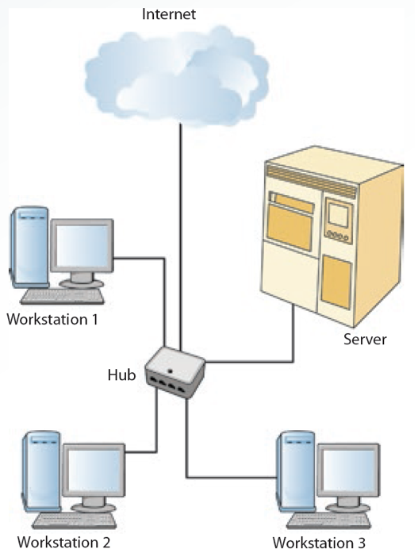

* + Wide Area Network (WAN): spans several cities, states, or countries and is owned by different parties.

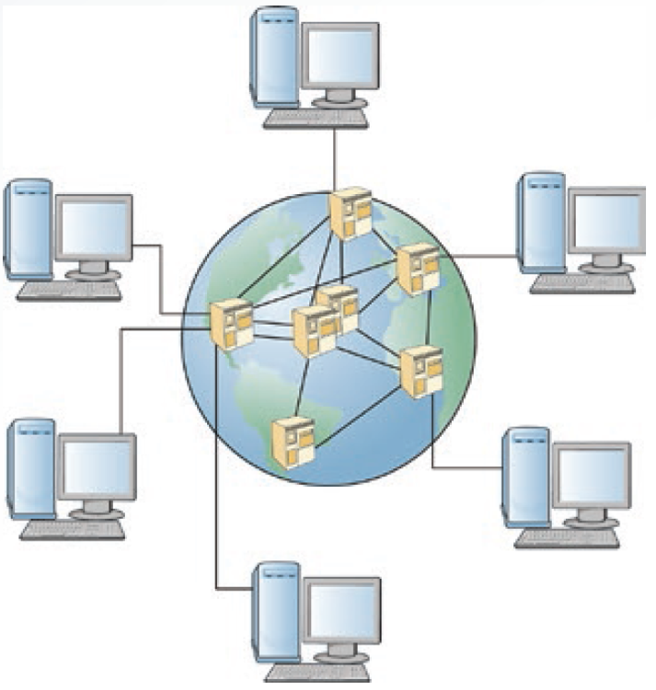

* + Metropolitan Area Network (MAN): designed to handle data communication for multiple organizations in a city and nearby cities as well.

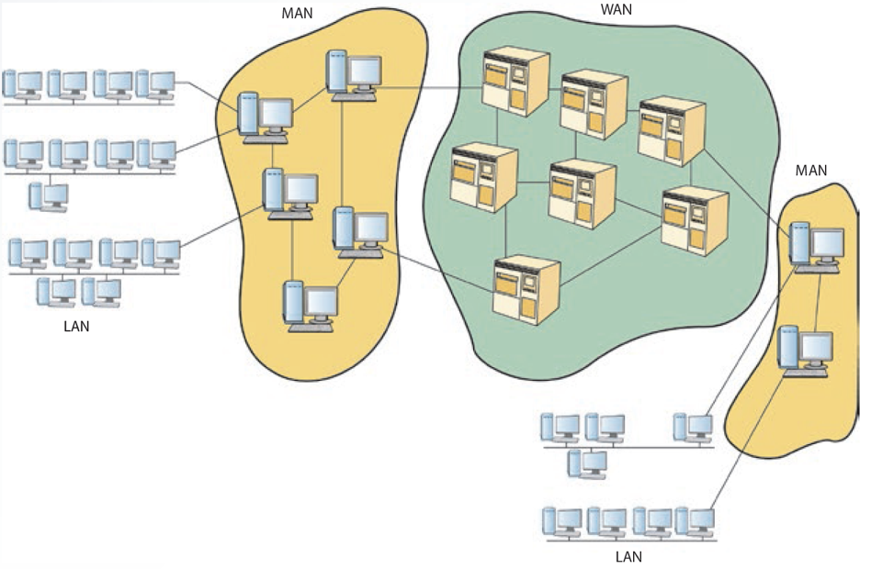

**Network Topologies:**

* Represent a network’s physical layout, including the arrangement of computers and cables.
* Star
  + Consists of a central computer and a series of nodes.
  + Advantages:
    - Cable layouts are easy to modify.
    - Centralized control makes detecting problems easier.
    - Nodes can be added to the network easily.
    - Effective at handling short bursts of traffic.
  + Disadvantages:
    - If the central host fails, the entire network becomes inoperable.
    - Increases costs as many cables are required.
* Ring
  + No host computer is required, each computer manages its own connectivity
  + Each node is connected with two other nodes: upstream and downstream neighbors.
  + Transmission is in one direction.
  + Needs less cable than a star topology.
  + Diagnosing problems and modifying the network are difficult.
* Bus
  + Connects nodes along a network segment.
  + Ends of the cable are not connected.
  + Terminator: hardware device used at each end of the cable to absorb the signal.
  + Advantages:
    - Easy to extend and reliable.
    - Wiring layout is simple and uses the least amount of cable of any topology.
    - Best for handling steady traffic.
  + Disadvantages:
    - Fault diagnosis is difficult.
    - Bus cable can be a bottleneck when network traffic is heavy.
* Hierarchical
  + Combines computers with different processing strengths in different organizational levels.
  + Used by traditional mainframe networks. Mainframe computer is at the top and Front-end-processors (FEPs) are at the second level.
  + Controllers and multiplexers are at the third level.
    - Controller: hardware and software device that controls data transfer from a computer to a peripheral device.
    - Multiplexer: hardware device that allows several nodes to share one communication channel.
  + Terminal and workstations are at the bottom level.
  + Advantages: offers greater deal of network control and lower cost than star topology
  + Disadvantages:
    - Network expansion may pose a problem.
    - Traffic congestion at the root and higher-level nodes.
* Mesh
  + Every node is connected to every other node.
  + Known as a plex or interconnected.
  + Advantage: highly reliable.
  + Disadvantage: expensive and difficult to maintain and expand.

**Protocols:**

* Agreed-on methods and rules that electronic devices use to exchange information.
  + Deal with hardware connections, control data transmission, and files transfers.
  + Specify the format of message packets sent between computers.
* Transmission Control Protocol / Internet Protocol:
  + Industry-standard suite of communication protocols that enables interoperability.
  + Allows the linking of devices running on many different platforms.
  + TCP:
    - Operates at the OSI model’s Transport layer.
    - Establishes a link between hosts.
    - Ensures message integrity and sequences and acknowledges packet delivery.
    - Regulates data flow.
  + IP:
    - Operates at the OSI model’s Network layer.
    - Divided into network address and node address.

**Routing:**

* Packet
  + Collection of binary digits sent from computer to computer over a network.
  + Includes message data and control characters for formatting and transmitting.
* Routing:
  + Process of deciding which part data takes.
  + Determined by the type of network and the software used to transmit data.
  + Routing table generated automatically by software (determines the best route for a packet).
  + Decision about selecting a route to follow on a network.
  + Centralized routing: one node is in charge of selecting the path for all packets.
  + Distributed routing: relies on each node to calculate its own best possible route.
* Routers:
  + Network connection device containing software that connects network systems and controls their traffic flow.
  + Choose the best path for packets based on distance or cost.
  + Prevent network jams that delay packet delivery.
  + Handle packets of different sizes.
  + Static: requires the network routing manager to give it information about which addresses are on which network.
  + Dynamic: can build tables that identify addresses on each network; used more often now, particularly on the Internet.

**Client/Server Model:**

* Software runs on the local computer and communicates with the remote server to request information or services.
  + Server: remote computer on the network that provides information or services in response to client requests.
  + Advantage: scalability.
* Levels of logic:
  + Presentation: how data is returned to the client.
  + Application: software processing requests for users.
  + Data management: data management and storage operations.

**Two-Ties Architecture:**

* Client communicates directly with the server. (effective in small workgroups)
* Advantages: application development speed, simplicity, and power.
* Drawback: changes in application logic require modifications of clients, resulting in upgrade and modification costs.

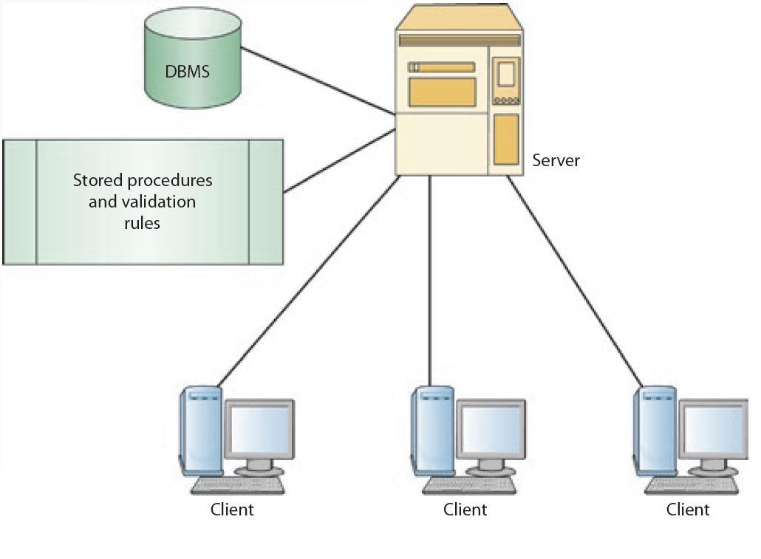

**N-Tier Architectures**

* Attempt to balance the workload between client and server.
  + Remove application processing from client and server and place it on a middle tier.
  + Advantage: improved network performance.
  + Drawbacks:
    - Consist of more network traffic.
    - Testing the software is difficult.

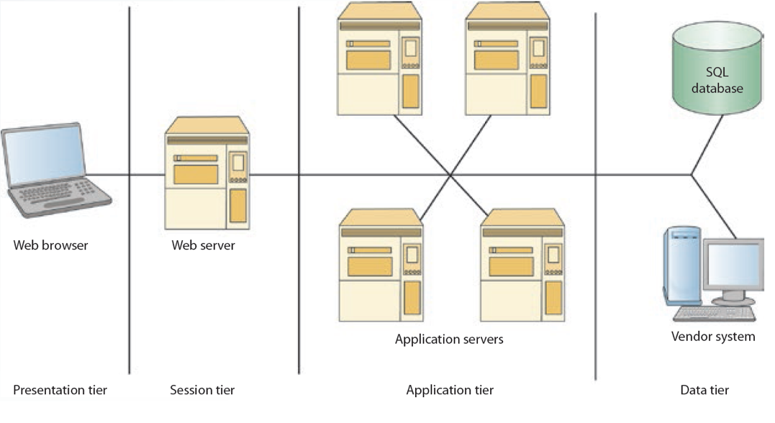

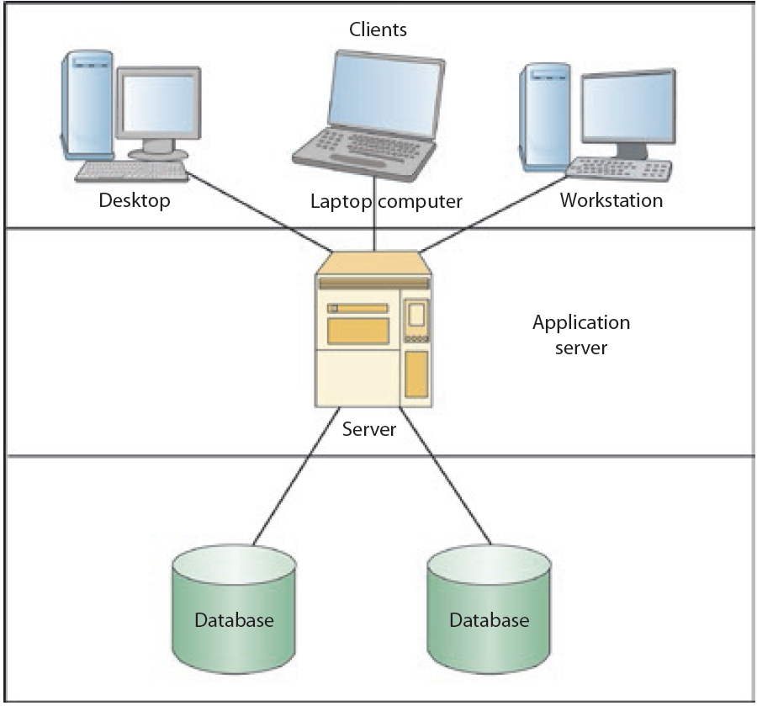

**Wireless and Mobile Networks**

* Wireless network: use wireless instead of wired technology.
* Mobile network: network operating on a radio frequency (RF).
  + Consists of radio cells, each served by a fixed transmitter, known as cell site or base station.
* Advantages:
  + Mobility, flexibility, and ease of installation.
  + Low cost.
* Disadvantages:
  + Limited throughput and range.
  + In-building penetration problems.
  + Vulnerability to frequency noise.
  + Security.

**Wireless Technologies**

* Wireless LANs
  + Alternative to wired LANs.
  + Characterized by having one owner and covering a limited area.
* Wireless WANs
  + Cover a broader area than WLANs.

**Mobile Networks**

* Consist of a three-part architecture
  + Base stations.
  + Mobile telephone switching offices (MTSOs)
  + Subscribers.
* Technologies developed to improve efficiency and quality.
  + Time Division Multiple Access (TDMA)
  + Transmits multiple encoded messages over a wide frequency and then decodes them at the receiving end.

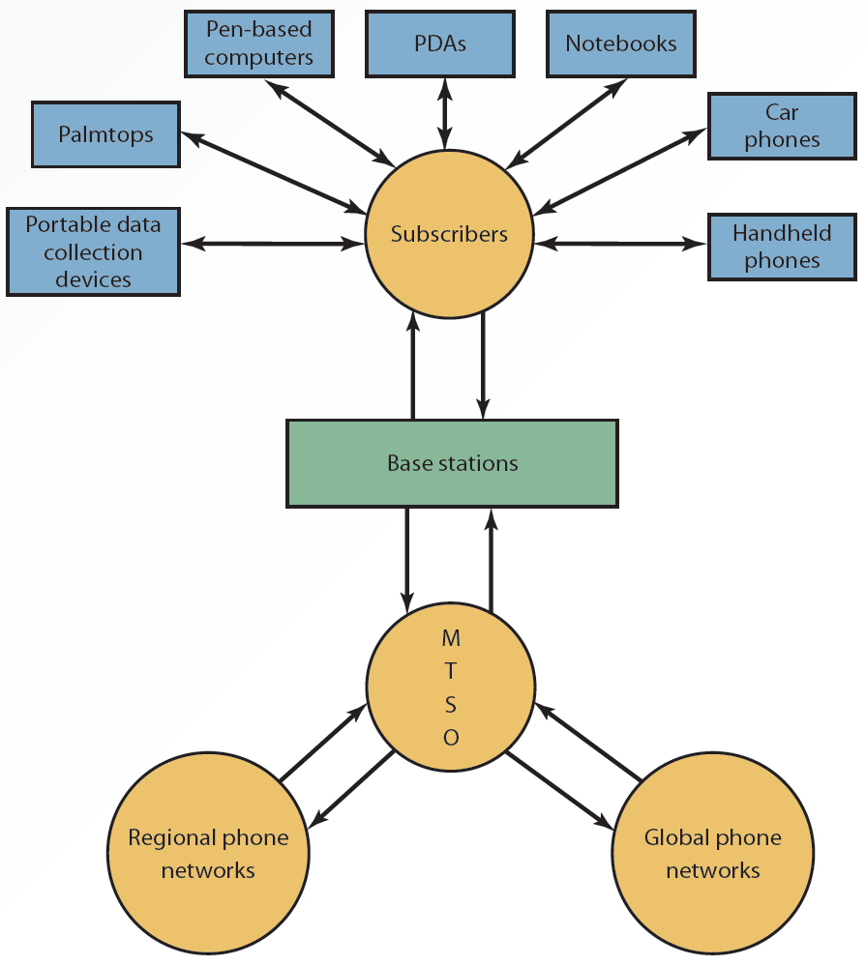

**Wireless Security**

* Service Set Identifier (SSID).
* Wired Equivalent Privacy (WEP).
* Extensible Authentication Protocol (EAP).
* Wi-Fi Protected Access (WPA).
* WPA2 or 802.11i.

**Convergence of Voice, Video, and Data**

* Convergence:
  + Integrating voice, video, and data so that multimedia information can be used for decision making.
  + Possible because of a combination of:
    - Technological innovation.
    - Changes in market structure.
    - Regulatory reform.
* Applications of convergence:
  + E-commerce.
  + Increased availability of entertainment options.
  + Increased availability and affordability of video and computer conferencing.
  + Consumer products and services.

**Slide 07: The Internet, Intranets, and Extranets.**

**The Internet and The World Wide Web**

* Internet: worldwide collection of millions of computers and networks of all sizes.
  + Network of network.
  + Started at 1969 as a project by the U.S. Department of Defense called Advanced Research Projects Agency Network (ARPANET)
  + Evolved into the national Science Foundation Network (NSFNET) in 1987.
* The Internet Backbone: foundation network linked with fiber-optic cables that can support high bandwidth.
  + Made up of many interconnected government, academic, commercial, and other high-capacity data routers.
  + Private companies operate their own internet backbone that interconnect at network access points (NPAs)
* WWW: changed the Internet in 1989.
  + Introduced a graphical interface to text-based Internet.
  + Organizes information by using hypermedia.
    - Documents include embedded references to audio, text, images, video, and other documents.
  + Hypertext: embedded references in hypermedia documents.
* Server or Web server
  + Any computer that stores hypermedia documents and makes them available to other computers on the internet.
* Exciting features of the Web
  + Hypermedia can be stored anywhere in the world, so users can jump from a site in the U.S. to a site in France in a few milliseconds.

**The Domain Name System**

* Domain names: unique identifiers of computer or network addresses on the Internet.
* Internet Protocol (IP) address: assigned by the Internet Corporation for Assigned Names and Numbers (ICANN)
* Domain Name Systems (DNS): protocol that converts domain names into IP addresses when information is transferred from one network to another.
* Domain names are used to identify a Web page in uniform resource locators (URLs).
  + Refer to the address of a document or site.
  + Have a suffix that indicates the top-level domain (TLD).
  + Denotes the type of organization or country the address specifies.
  + Divided: top-level domains (gTLDs) and country code top-level domains (ccTLDs).

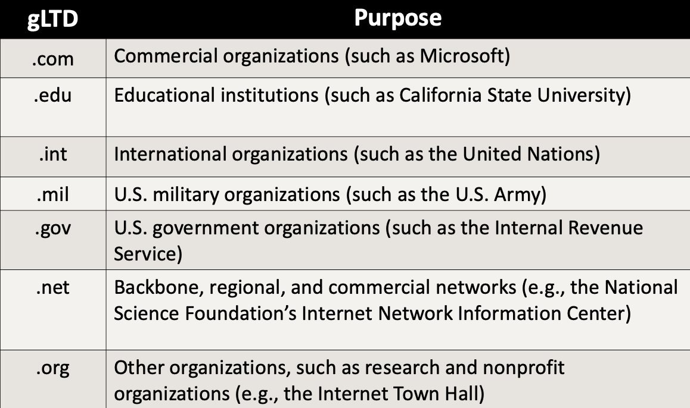

**Types of Internet Connections**

* Dial-up modems.
* Cable modems.
* Digital Subscriber Line (DSL).
* Symmetric DSL (SDSL).
* Asymmetric DSL (ADSL).
* Very High-Speed DSL (VDSL)

**Navigational Tools, Search Engines, and Directories**

* Navigational tools: used to travel from Web site to Web site.
* Search engines: enable users to retrieve information from the Internet by using keywords.
* Directories: indexes of information based on keywords embedded in documents; allow search engines to find required information.

**Navigational Tools**

* Graphical Web browsers: Microsoft Internet Explorer (IE), Mozilla Firefox, Google Chrome, Apple Safari, and Opera.
  + Viewing browsing history.
  + Bookmarking favorite Web sites.
  + Setting viewing preferences.
  + Navigation buttons.

**Search Engines and Directories**

* Crawling the Web:
  + Search engines use software called crawlers, spiders, and bots to search the Web continuously for a new data.
  + Gathered data is sent back to search engine’s data center to ensure that it has the most current information on the Web.
* Indexing:
  + Housed at server farms, search engines use keywords to index data coming in from crawlers.
  + Each keyword has an entry that is linked to all Web pages containing that keyword.
* Searching:
  + Search engine uses the index created during the indexing step to look up the search term.
  + Identifies all Web pages linked to the term if the term exists in the index.
  + Varies in intelligence.
* Automated or crawler-based directory creates indexes of search terms and collects these terms automatically by using crawlers.
* Human-powered directory: it requires keywords to be manually submitted for a Web page to be listed in a search engine’s results.
* Relies on users to supply data.

**Internet Services**

* Made possible by the TCP suite of protocols:
  + TCP/IP provides useful e-mail protocols.
    - Simple Message Transfer Protocol (SMTP)
    - Post Office Protocol (POP)
  + Popular services:
    - E-mail, newsgroup, discussion groups, Internet Relay Chat (IRC), instant messaging, and Internet telephony.

**E-mail**

* Widely used services on the Internet.
  + Web-based e-mail.
  + Client-based e-mail.
* Programs:
  + Folders to organizing e-mails.
  + Addresses book and distribution groups.
  + Spell checkers and delivery notifications.

**Newsgroups and Discussion Groups**

* Discussion groups:
  + Formed for people to exchange opinions and ideas on a specific topic.
  + Group members post messages or articles that others in the group can read.
* Newsgroups:
  + General in nature and can cover any topic.
  + Allow people to get together for fun or for business purposes.

**Instant Messaging**

* Internet Relay Chat (IRC): enables users in chat rooms to exchange text messages with people in other locations in real time.

[INCOMPLETE]

**Slide 08: E-Commerce**

**Defining E-Commerce**

* E-business
  + All activities a company performs for selling and buying products and services using computer and communication technologies.
* E-commerce
  + Buying and selling goods and services over the internet.
  + Builds on traditional commerce by adding the flexibility that networks offer and the availability of the internet.
* Business Applications
  + Buying and selling products and services.
  + Collaborating with other companies.
  + Communicating with business partners.
  + Gathering business intelligence on customers and competitors.
  + Providing customer service.
  + Suppling software updates and patches.
  + Offering vendor support.
  + Publishing and disseminating information.

**The Value and E-Commerce**

* Value chain
  + Series of activities designed to meet business needs by adding value or cost in each phase of the process.
* Primary activities
  + Inbound logistics.
  + Operations.
  + Outbound logistics.
  + Marketing and sales.
  + Service.
* The Internet
  + Increases the speed and accuracy of communication between suppliers, distributors, and customers.
  + Low cost means companies of any size can participate in value chain integration.
* E-commerce enhances a value chain
  + Offers new ways to reduce costs or improve operations.

**Michael Porter’s Value Chain**

**E-Commerce vs. Traditional Commerce**

* Click-and-brick e-commerce:
  + Mixes traditional commerce and e-commerce.
  + Capitalizes on the advantages of online interactions with customers.
  + Retains the benefits of having a physical store location.

**Advantages and Disadvantages of E-Commerce**

* Advantages
  + Enhances relationships with suppliers, customers, and business partners.
  + Creates price transparency.
  + Operates around the clock and globe.
  + Gathers more information on potential customers.
  + Increases customer involvement.
  + Improves customer service.
  + Increases flexibility, ease of shopping, number of customers, opportunities for collaboration with business partners, and return on investment.
  + Offers personalized services and product customization.
  + Reduces administrative and transaction costs.
* Disadvantages
  + Bandwidth capacity problems.
  + Security and privacy issues.
  + Accessibility.
  + Acceptance.

**E-Commerce Business Models**

* E-commerce companies focus their operations on different parts of the value chain to achieve profitability.
  + Traditional e-commerce models are an extension or revision of traditional business models.
* Merchant model
  + Transfers the old retail model to the e-commerce world by using the Internet.
* Brokerage model
  + Brings the seller and buyers together on the Web and collects commissions on transactions between them.
* Advertising model:
  + Extension of traditional advertising media.
  + Directories such as Yahoo! Provide content to users for free.
* Mixed model:
  + Generating revenue from more than one source.
* Infomediary model
  + E-commerce sites collect information on consumers and businesses and then sell this information to other companies for marketing purpose.
* Subscription model
  + E-commerce sites sell digital products or services to customers.
* Business-to-consumer (B2C)
  + Companies sell directly to consumers and supplement traditional commerce with e-commerce.
    - Information sharing.
    - Ordering.
    - Payment.
    - Fulfillment.
    - Service and support.
* Business-to-business (B2B)
  + Involver electronic transactions between business, such as electronic data interchange (EDI) and electronic funds transfer (EFT).
  + Technologies:
    - Intranets and extranets.
    - Virtual private networks.
    - Electronic data interchange (EDI).
    - Electronic funds transfer (EFT).
  + Advantages:
    - Reduces delivery time and costs.
    - Improves communication.
  + Models based on who controls the marketplace
    - Seller.
    - Buyer.
    - Intermediary (third party).
    - Trading partner agreements.
* Consumer-to-consumer (C2C)
  + Involves business transactions between users.
  + Includes the usage of online classified ads or online auction sites.
* Consumer-to-business (C2B)
  + Involves people selling products or services to business.

**Major Categories of E-Commerce**

* Nonbusiness organizations that use e-commerce applications.
  + Universities.
  + Nonprofit organizations.
  + Political and social organizations.

**Organizational or Antibusiness E-Commerce**

* Involves e-commerce activities that take place inside an organization via the organization’s intranet.
  + Exchange of goods, services, or information among employees.
  + Conducting training programs and offering human resource services.

**Seller-Side Marketplace**

* Sellers who cater to specialized markets come together to create a common marketplace for buyers.
* E-procurement
  + Enables employees to order and receive supplies and services directly from suppliers.
  + Prevents purchases from suppliers that are not on the approved list of sellers.
  + Eliminates the processing costs of purchases.

**Buyer-side Marketplace**

* Buyer, or a group of buyers, opens an electronic marketplace and invites sellers to bid.
  + Help buyers manage the procurement process more efficiently, lower administrative costs, and implement uniform pricing.
  + Involves the goals of establishing new sales channels.

**Trading-Party Exchange Marketplace**

* Marketplace generates revenue from the fees charged for matching buyers and sellers.
  + Vertical market concentrates on a specific industry or market.
  + Horizontal market concentrates on a specific function or business process and automates it for different industries.
* Offers suppliers a direct channel of communication to buyers.

**Trading Partner Agreement**

* Automate negotiating processes and enforce contracts between participating businesses.
  + Allow business partners to send and receive bids, contracts, and information needed.
  + Enable customers to submit documents via the internet.

**Mobile and Voice-Based E-Commerce**

* Mobile commerce (m-commerce): using handheld devices to conduct business transactions. (Based on WAP.)
* Supports wireless 3G and 4G.
* Voice-based e-commerce relies on voice recognition and text-to-speech technologies.
* E-wallets.
* Call and voice recognition.
* Shipping to a set address that cannot be changes by voice commands.

**Chapter 8**

**E-business** encompasses all the activities a company performs in selling and buying product and services using computers and communication technologies.

**E-commerce** is buying and selling goods and services over the Internet.

A **value chain** is a series of activities designed to meet business needs by adding value (or cost) in each phase of the e-commerce process. The value chain is about understanding what aspects of an organization’s business add value for customers and then maximizing those aspects.

**Click-and-brick e-commerce** mixes traditional commerce and e-commerce. It capitalizes on the advantages of online interaction with customers yet retains the benefits of having a physical store location.

*E-commerce business models*

The **merchant model** transfers the old retail model to the e-commerce world by using the medium of the internet.

Using the **brokerage model** brings sellers and buyers together on the web and collects commissions on transactions between these parties

The **advertising model** is an extension of traditional advertising media, such as radio and television. Directories such as Yahoo! Provide content (similar to radio and TV) to users for free. By creating more traffic with this free content, they can charge companies for placing banner ads or leasing spots on their sites.

The **mixed model** refers to generating revenue from more than one source

Under the **infomediary model**, e-commerce sites collect information on consumers and businesses and then sell this information to other companies for marketing purposes

Under the **subscription model**, e-commerce sites sell digital products or services to customers.

*Major categories of e-commerce*

**Business-to-consumer (B2C)** consumer sell directly to consumers

**Business-to-business (B2B**) e-commerce involves electronic transactions between business

**Consumer-to-consumer (C2C)** e-commerce involves business transactions between users, such as consumers selling to other consumers via the internet.

**Consumer-to-business (C2B)** e-commerce involves people selling products or services to businesses, such as when a consumer creates online surveys for a company to use.

**E-government applications** can include government to-citizen, government-to-business, government-to-government and government-to-employee transactions. Services include tax filling, online voter registration, disaster assistance, and e-training for government employees.

**Organizational (intrabusiness)** e-commerce involves e-commerce activities that take place inside an organization, typically via the organization’s intranet. These activities can include the exchange of goods, services, or information among employees

*B2C E-Commerce Cycle*

**Information sharing -> ordering -> payment -> fulfillment -> service and support**

*Major models of B2B E-Commerce*

The **seller-side marketplace** model occurs most often. In this model, sellers who cater to specialized markets, such as chemicals, electronics and auto components, come together to create a common marketplace for buyers – sort of a one-stop shopping model.

**E-procurement** enables employees in an organization to order and receive supplies and services directly from supplies

In a **buyer-side marketplace** model, a buyer, or a group of buyers, opens an electronic marketplace and invites sellers to bid on announced products or make a request for quotation (RFQ). Using this model, buyers can manage the procurement process more efficiently, lower administrative costs and implement uniform pricing.

The **third-party exchange** marketplace model is not controlled by sellers or buyers. Instead, it is controlled by a third party, and the marketplace generates revenue from the fees charged for matching buyers and sellers.

A **vertical market** concentrates on a specific industry or market. The utilities industry, the beef and dairy industries, and the sale of medical products are examples of vertical markets.

A **horizontal market** concentrates on a specific function or business process and automates this function or process for different industries

**Trading partner agreements** automate negotiating processes and enforce contracts between participating business

*Mobile and voice-based e-commerce*

**Mobile commerce (m-commerce)** is using handheld devices, such as smartphones or PDAs, to conduct business transactions

**Voice based** e-commerce relies on voice recognition and text-to-speech technologies

*E-commerce supporting technologies*

**Electronic payment** refers to money or scrip that is exchanged electronically. It usually involves use of the internet, other computer networks, and digitally stored value systems. It includes credit cards, debit cards, charge cards, and smart cards.

A **smart card** is about the size of a credit card and contains an embedded microprocessor chip for storing important financial and personal information. The chip can be loaded with information and updated periodically.

**E-cash**, a secure and convenient alternative to bills and coins, complements credit, debit, and charge cards and add adds convenience and control to everyday cash transactions.

An **e-check**, the electronic version of a paper check, offers security, speed, and convenience for online transactions.

**E-wallets,** which are available for most handheld devices, offer a secure, convenient, and portable tool for online shopping. They store personal and financial information, such as credit card numbers, passwords, and PINs.

**Paypal** is a popular online payment system used for many online transactions. Users with valid e-mail addresses can set up accounts and make secure payments for online transactions using their credit cards or bank accounts.

**Micropayments** are transactions on the web involving very small amounts of money. They began as a method for advertisers to pay for cost per view or cost per click.

*Web marketing*

**Web marketing** uses the web and its supporting technologies to promote goods and services

**Search Engine Optimization (SEO)** is a method for improving the volume or quality of traffic to a web site. A higher ranking in search results should generate more revenue for a web site.

*Social commerce*

**Social commerce** is a subset of e-commerce that is influenced by social networks and other online media

*Hyper-social Organizations*

**Hyper-social organizations** are companies that leverage social media to better connect with customers and increase sales through the social process

**Chapter 10**

**Systems development life cycle (SDLC),** also known as the “waterfall model”, is a series of well-defined phases performed in sequence that serves as a framework for developing a system or project.

*Phase 1*

During the **planning phase**, which is one of the most crucial phases of the SDLC model, the systems designer must define the problem the organization faces, taking care not to define symptoms rather than the underlying problem.

**Internal users** are employees who will use the system regularly, and they can offer important feedback on the system’s strengths and weaknesses.

**External users** are not employees but do use the system; they include customers, contractors, suppliers, and other business partners. Although they are not normally part of the task force, their input is essential.

**Joint application design (JAD)** is a collective activity involving users, top management, and IT professionals. It centers on a structured workshop (called a JAD session) where users and system professionals come together to develop an application.

A **feasibility study** analyzes a proposed solution’s feasibility and determines how best to present the solution to management. It usually has five major dimensions: economic, technical, operational, scheduling, and legal.

**Economic feasibility** assesses a system’s costs and benefits.

**Technical feasibility** is concerned with the technology to be used in the system. The team needs to assess whether the technology to support the new system is available or feasible to implement.

**Operational feasibility** is the measure of how well the proposed solution will work in the organization and how internal and external customers will react to it.

**Scheduling feasibility** is concerned with whether the new system can be completed on time.

**Legal feasibility** is concerned with legal issues, including political repercussions and meeting the requirements of the information privacy act.

*Phase 2*

In the **requirements-gathering and analysis phase**, analysts define the problem and generate alternatives for solving it.

*Phase 3*

During the **design phase** analysts choose the solution that is the most realistic and offers the highest payoff for the organization. Details of the proposed solution are outlined, and the output of this phase is a document with exact specifications for implementing the system, including files and databases, forms and reports, documentation, procedures, hardware and software, networking components, and general system specifications.

**Computer-aided systems engineering (CASE)** tools automate parts of the application development process. These tools are particularly helpful for investigation and analysis in large scale projects because they automate parts of the design phase.

In **phototyping**, a small-scale version of the system is developed, but one that is large enough to illustrate the system’s benefits and allow users to offer feedback.

A **proof-of-concept prototype** shows users how a particular task that was not technically feasible can be done.

A **selling prototype** is used to sell a proposed system to users or management by showing some of its features

*Phase 4*

During the **implementation phase**, the solution is transferred from aper to action, and the team configures the system and procures components for it.

In **parallel conversion**, the old and new systems run simultaneously for a short time to ensure the new system works correctly.

In **phased-in-phased-out conversion**, as each module of the new system is converted, the corresponding part of the old system is retired. This process continues until the entire system is operational.

In **plunge (direct cutover) conversion** the old system is stopped and the new system is implemented.

In **pilot conversion**, the analyst introduces the system in only a limited area of the organization, such as a division or department. If the system works correctly, it is implemented in the rest of the organization in stages or all at once.

**IT project management** includes activities required to plan, manage and control the creation and delivery of an information system

**A Request for Proposal (RFP)** is a written document with detailed specifications that is used to request bids for equipment, supplies, or services from vendors

**A Request for Information (RFI)** is a screening document for gathering vendor information and narrowing the list of potential vendors. It can help manage the selection of vendors by focusing on the project requirements that are crucial to selecting vendors.

**Insourcing** happens when an organization’s team develops the system internally.

**Self-sourcing** is when end users develop their own information systems, with little or no formal assistance from the information systems team. These users might not know how to write programming code, but they are typically skilled enough to use off-the-shelf software, such as spreadsheet and database packages, to produce custom built applications.

With the **outsourcing approach**, an organization hires an external vendor or consultant who specializes in providing development services

**Crowdsourcing** is the process of outsourcing tasks that are traditionally performed by employees or contractors to a large group of people (a crowd) through an open call

*Phase 5*

During the **maintenance phase**, the information system is operating, enhancements and modifications to the system have been developed and tested, and hardware and software components have been added or replaced

*New trends in systems analysis and design*

**Service-oriented architecture (SOA)** is a philosophy and a software and system development methodology that focuses on the development, use, and reuse of small, self-contained blocks of code (called services) to meet the software needs of an organization

**Rapid application development (RAD)** concentrates on user involvement and continuous interaction between users and designers. It combines the planning and analysis phases into one phase and develops a prototype of the system. It uses an iterative process (also called “incremental development”) that repeats the design, development, and testing steps as needed, based on feedback from users

**Extreme programming (XP)** is a method for developing software applications and information system projects in which the project is divided into smaller functions and developers cannot go on to the next phase until the current phase is finished. Each function of the overall project is developed in a step-by-step fashion.

**Pair programming** is where two programmers participate in one development effort at one workstation. Each programmer performs the action the other is not currently doing.

**Agile methodology** is similar to XP in focusing on an incremental development process and timely delivery of working software. However, there is less emphasis on team coding and more emphasis on limiting the project’s scope

**Slide 11: Enterprise Systems**

**Supply Chain Management**

* Supply chain:
  + Integrated network consisting of an organization, its suppliers, transportation companies, and brokers.
  + Used to deliver goods and services to customers.

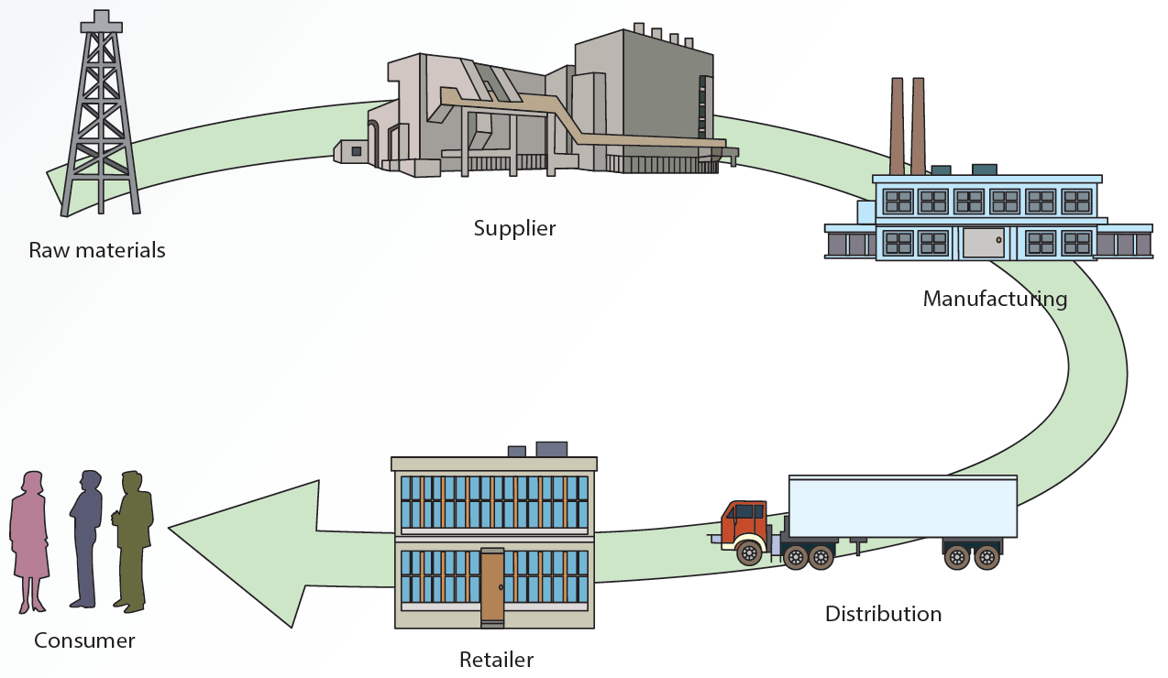

* Supply chain management (SCM):
  + Process of working with suppliers and other partners in the supply chain.
  + Aim is to improve procedures for delivering products and services.
  + Coordinates several functions:
    - Procuring materials.
    - Transforming materials into intermediate and finished products or services.
    - Distributing finished goods to customers.
  + Communication in a firms SCM system
    - Takes place among product flow, information flow, and finances flow.
  + Key decision in SCM related to manufacturing: location, inventory, production and transportation.
  + Green logistic is a growing trend among SCM.

**SCM Technologies**

* Major roles in implementing SCM systems: information technologies, the internet.

**Electronic Data Interchanges:**

* Enables business partners to exchange information on business transactions.
* Expedites the delivery of accurate information.
* Web-based EDI or OPEN EDI
  + Using the Internet and web protocols to transmit documents.
  + Lower costs of transmitting documents.
  + Platform independent and easy to use.
* Drawbacks:
  + Uses proprietary standards.
  + Cost per partner is higher when the number of partners is small.
  + Reduced popularity.

**Internet-Enabled SCM:**

* Improves information sharing throughout the supply chain.
  + Reduces cost for information transmission and improves customer service.
* Improves several SCM activities:
  + Purchasing, procurement and scheduling.
  + Inventory management and transportation.
  + Order processing and customer service.

**E-Marketplaces:**

* Third-party exchange (B2B model): provide a platform for buyers and sellers to interact and trade more efficiently online.
* Help maintain a competitive edge:
  + Provides opportunities for partnerships.
  + Offers a single platform and reduces costs.
  + Solves international time-constraint problems.
  + Makes it easy to compare prices and products.
* An e-distributor is a marketplace owned and operated by a third-party that provides:
  + Electronic catalog of products.
  + Maintenance, repair, and operations (MROs) services.
  + Fast delivery of a wide selection of products and services at lower prices.
  + Assistance for companies to reduce the time and expense of searching for goods.

**Online Auctions:**

* Bring traditional auctions to customers around the globe.
  + Make it possible to sell far more goods and services than a traditional auction.
  + Based on the brokerage business model.
  + Cost-effective for selling excessive inventory.
* Reverse-auctions: sellers submit bids. (One-to-many relationship)

**Collaborative Planning, Forecasting, and Replenishment:**

* Used to coordinate supply chain members through point-of-sales (POS) data sharing and joint planning.
* Goal is to improve operational efficiency and manage inventory.
* Advantage: decreases merchandising, inventory, and logistics costs for all supply chain members.
* Collaboration part of the process is the agreement between all supply chain partners that establishes how:
  + Data is shared.
  + Problems with overstock are solved.
  + Costs are shared or minimized.
* Exception management:
  + Planning for handling unforeseen problems.
  + Lessons learned can be used in future planning.

This image depicts the collaborative planning, forecasting, and replenishment process. It consists of an oval that has been placed at the center of the illustration. Three concentric circles surround this oval. The oval is labeled consumer. 
The entire illustration has been divided into four quadrants via two dotted lines. The first line runs vertically through the illustration, and the second line runs horizontally through the illustration. In a clockwise manner of appearance, these quadrants are labeled strategy and planning, demand and supply management, execution, and analysis. 
The innermost circle is labeled retailer. In a clockwise manner of appearance, the content in this circle reads vendor management, category management, P O S forecasting, replenishment planning, buying or re-buying, logistics or distribution, store execution, and supplier scorecard. Vendor management and category management fall under the quadrant labeled strategy and planning. P O S forecasting and replenishment planning fall under the quadrant labeled demand and supply management. Buying or re-buying and logistics or distribution fall under the quadrant labeled execution. Store execution and supplier scorecard fall under the quadrant labeled analysis. 
In a clockwise manner of appearance, the content in the second circle reads collaborative arrangement, joint business plan, sales forecasting, order planning or forecasting, order generation, order fulfillment, exception management, and performance assessment. Each element is connected to the next via arrows. Collaborative arrangement and joint business plan fall under the quadrant labeled strategy and planning. Sales forecasting and order planning or forecasting fall under the quadrant labeled demand and supply management. Order generation and order fulfillment fall under the quadrant labeled execution. Exception management and performance assessment fall under the quadrant labeled analysis. 
The third and outermost circle is labeled manufacturer. In a clockwise manner of appearance, the content in this circle reads account planning, market planning, market data analysis, demand planning, production and supply planning, logistics or distribution, execution monitoring, and customer scorecard. Account planning and market planning fall under the quadrant labeled strategy and planning. Market data analysis and demand planning fall under the quadrant labeled demand and supply management. Production and supply planning and logistics or distribution fall under the quadrant labeled execution. Execution monitoring and customer scorecard fall under the quadrant labeled analysis.


**3D Printing:**

* Additive manufacturing: making an object from a digital model.
* Plays a major role in SCM:
  + Significant reduction in manufacturing times.
  + Effectiveness in meeting customer demands.
  + Elimination of the need to carry inventory.
  + Quicker delivery of designs to the market.
  + Efficiency in the use of materials.

**Drones:**

* Specialized robot that is designed to fly and perform certain automated tasks.
  + Available in various shapes and sizes
  + Vary in sophistication.
* Several SCM uses:
  + Count, carry and deliver inventory.
  + Supervise animals in agriculture.
  + Perform maintenance tasks in dangerous environments.

**Internet of Things (IoTs):**

* Help achieve several goals:
  + Reduces inventory loss in warehouse or in transit.
  + Reduces fuel costs.
  + Ensures temperature stability during product transit.
  + Manage warehouse inventory for out-of-stock inventory.
  + Improves customer service and gathers BI regarding product usage.

**Customer Relationship Management:**

* Customer relationship management (CRM) processes a company uses to track and organize its contacts with customers:
  + Improves services offered to customers.
  + Uses customer contact information for targeted marketing.
  + Helps organizations make better use of data, information, and knowledge to understand customers.
* Marketing strategies focus on long-term relationship and include:
  + Identifying customer segments and a company’s profitable and loyal customers.
  + Improving products to meet customer needs and customer retention.
* Provides a complete picture of an organization’s customers: complex analyses on customer data.
* Activities in a CRM system:
  + Sales automation.
  + Order processing.
  + Marketing automation.
  + Customer support.
  + Knowledge management.
  + Personalization technology.
* Implemented with one of two approaches:
  + On-premises CRM.
  + Web-based CRM.
* Software packages available for setting up a CRM system.
  + Amdocs CRM, Optima Technologies ExSellence, Infor CRM, SAP CRM, and Oracle CRM.
* Features of CRM software packages:
  + Salesforce automation.
  + eCRM or Web-based CRM.
  + Survey management.
  + Automated customer service.

**Personalization Technology:**

* Personalization:
  + Process of satisfying customer’s needs, building customer relationships, and increasing profits.
  + Achieved by designing goods and services that meet customer’s preferences better.
* Customization:
  + Allows customers to modify the standard offering.
  + Example: selecting different home page to be displayed each time the Web browser is opened.
  + Requires gathering customer information: may affect customers’ sense of privacy.
  + Implementation requires:
    - Internet and databases.
    - Data warehouse/ data marts.
    - Data mining tools.
    - Mobile networks.
    - Collaborative Filtering (CF).
      * Search for a specific information or pattern using input from multiple business partners and data sources.
      * Identifies groups of people based on common interests and recommends products.
      * Works well for a single product category.
      * Collaborative filtering drawbacks:
        + Needs a large sample of users and content work well.
        + Fails to make recommendations across unrelated categories.
      * Application: making automatic predictions about customer preferences based on similar users.

**Knowledge Management:**

* Knowledge management (KM) is a technique used. To improve CRM systems.
* Identifying, storing, and disseminating “know-how” – facts about how to perform tasks.
* Draws on concepts of organizational learning, culture, and best practices to:
  + Convert tacit knowledge into explicit knowledge.
  + Create a knowledge-sharing culture in an organization.
  + Eliminate obstacles to sharing knowledge.
* Can be accessed by employees when needed and use when new products are designed.
* Tracks how often an employee participates in knowledge-sharing interactions.
* Tools and technologies:
  + Groupware to create, manage, and distribute documents in an organization.
  + DBMSs and data-mining tools.
  + Decision support systems.
* Contribution to an organization:
  + Promote innovation by encouraging free exchange of ideas.
  + Improve customer service by reducing response time.
  + Increase revenue by reducing the delivery time for products and services.
  + Improve employee retention rates by rewarding employees for their knowledge.
* Chief of knowledge officer (CKO) ensures:
  + Knowledge resources are collected, stored, and disseminated among key decision makers.
  + Organization profits from knowledge resources.
  + Return on investment (ROI) is maximized.
    - KM and knowledge management systems
    - Processes

**Enterprise Resource Planning (ERP):**

* Collect and processes data.
* Manages and coordinates resources, information, and functions.
* Includes hardware, software, procedures, and input from all functional areas.
* Systems use a unified database to store data for various functions.

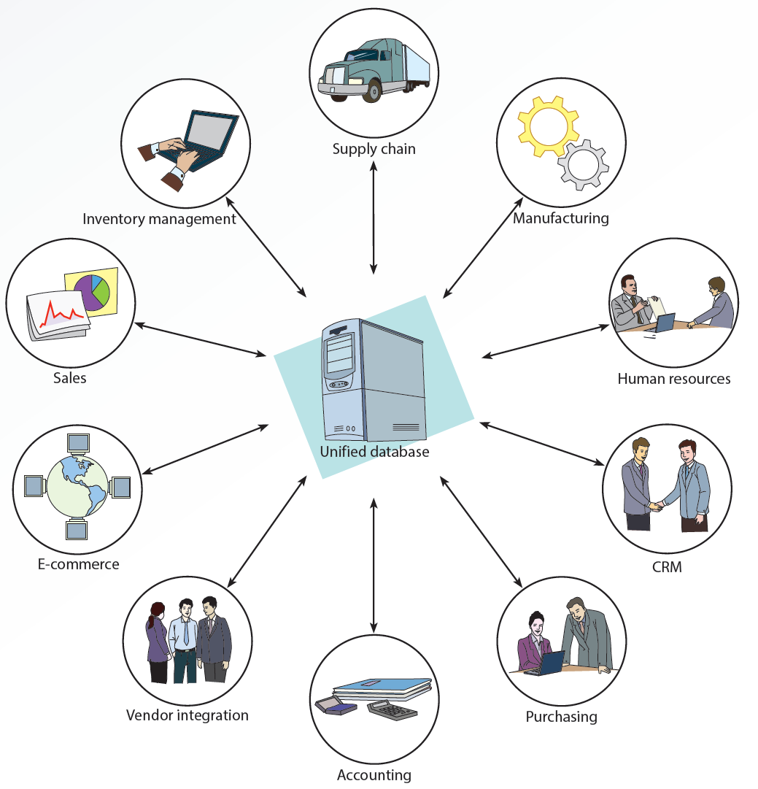

* Benefits:
  + Increased availability and timeliness of integrated information.
  + Increased data accuracy and response time.
  + Improved customer and employee satisfaction, planning and scheduling, supplier relationship, and reliability of information.
  + Reduced inventory costs, labor costs, and order to-fulfillment time.
* Drawbacks:
  + High cost.
  + Difficulties in installation.
  + Need for extensive training.
  + Compatibility problems with legacy systems.
* Available as modules so organizations can purchase only required components.

**Slide 12: Management Support System**

**Types of Decisions in an Organization**

* Structured decisions:
  + Can be automated because a well-defined standard operating procedure exists for these types of decisions.
  + Known as programable tasks.
* Semi structured decisions:
  + Include a structured aspect that benefits from information retrieval, analytical models, and information systems technology.
* Unstructured decisions:
  + One-time decisions with no standard operating procedure.
  + Decision maker’s intuition plays an important role as information technology offers less support for the decisions.
* Challenges in semi structured and unstructured decisions:
  + Multiple criteria and users must choose between conflicting objectives.

This figure illustrates a diagram explaining the organizational levels and types of decisions. It is in the form of a triangle that has been divided into three parts. The first part, at the base of the triangle, represents operational management. It contains three points. The first point reads unstructured, which relates to setting queue priorities. The second point reads semistructured, which relates to accounts receivable. The third point reads structured, which relates to payroll.
The second part of the triangle, which is in the middle, represents tactical management. It contains three points. The first point reads unstructured, which relates to resolving conflicts between two divisions. The second point reads semistructured, which relates to sales forecast. The third point reads structured, which relates to budget preparation.
The third part of the triangle, which is at the top, represents strategic management. It contains three points. The first point reads unstructured, which relates to introduction of a new product. The second point reads semistructured, which relates to mergers. The third point reads structured, which relates to plant location.


* Management Support Systems (MSSs):
  + Different types of information systems that have been developed to support certain aspects and types of decisions.
  + Each type is designed with unique goals and objectives.

**Phases of Decision Making**

* Herbert Simon defined three phases:
  + Intelligence phase
  + Design phase
  + Choice phase
  + Implementation phase
* Intelligence phase:
  + Decision maker examines the organization’s environment for conditions that need decisions.
  + Data is collected from a variety of sources and processed.
    - Allows decision maker to discover ways to approach the problem.
  + Information technology does not support this phase of decision making.
* Choice Phase:
  + Selecting the best and most effective course of action from the alternatives.
    - Analyzing each alternative and its relationship to the criteria to determine whether it is feasible.
  + Decision Support System (DSS):
    - Helps sort through possible solutions to choose the best one for the organization.
    - Includes tools for calculating cost-benefit rations.
* Implementation Phase:
  + Organization devises a plan for carrying out the alternative selected in the choice phase and obtains the resource to implement the plan.
    - DSS does a follow-up assessment on how well a solution is performing.

**Decision Support Systems:**

* Decision support Systems (DSS): interactive information system designed to assist decision makers in an organization.
  + Hardware.
  + Software.
  + Data.
  + Mathematical and Statistical models.
* Requirements of decision support systems
  + Be interactive.
  + Incorporate the human element as well as hardware and software.
  + Use internal and external data.
  + Include mathematical and statistical models.
  + Support decision makers at all levels.
  + Emphasize semi structured and unstructured tasks.
* Database:
  + Includes internal and external data and a database management system (DBMS).
  + Enables a DSS to perform data analysis.
* Model base:
  + Includes mathematical and statistical models.
  + Enable a DSS to analyze information.
* User Interface Component:
  + Allow users to access the DSS.

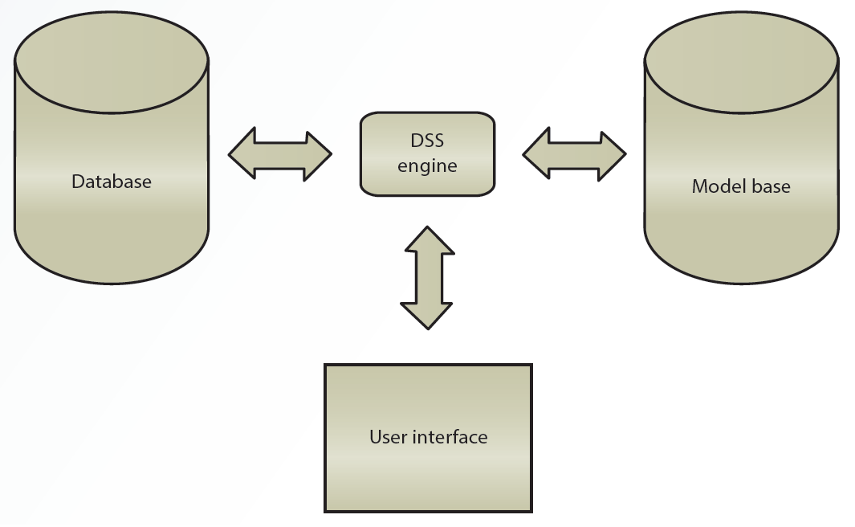

**DSS Capabilities:**

* DSS includes features to support decision making.
  + What-if analysis.
  + Goal-seeking.
  + Sensitivity and exception reporting analysis.
* Other capabilities
  + Graphical analysis, forecasting, simulation, statistical analysis, and modeling analysis.

**Roles in the DSS Environment:**

* Users.
  + Crucial because they use the DSS.
  + Include department or organizational units in addition to people.
* Managerial Designer
  + Defines the management issues in designing and using a DSS.
  + Issues are related to management’s goals and needs.
* Roles in the DSS Environment
  + Technical designer
    - Focused on how the DSS is implemented.
    - Addresses questions:
      * Data storage.
      * File Structure.
      * User access.
      * Response time.
      * Security measures.
  + Model builder
    - Liaison between users and designers.
    - Responsible for supplying information
      * What the model does.
      * What data inputs the model accepts.
      * How the model’s output should be interpreted.
      * What assumptions go into creating and using the model.

**Costs and Benefits of Decision Support Systems:**

* Benefits:
  + Increase in the number of alternatives examined.
  + Fast response to unexpected situations.
  + Ability to make one-of-a-kind decisions.
  + New insights and learning.
  + Improved communication, control, and decisions.
  + Cost and time savings.
  + Effective teamwork and use of data resources.

**Executive Information Systems (EISs):**

* Give executives easy access to internal and external data.
* Branch of DSSs.
* Include drill-down features and digital dashboard.
* Designers should focus on simplicity when developing a user interface.
* Adding features increases ease of use.
* Require access to both internal and external data.
* Must collect data related to an organization’s critical success factors.
* Include a digital dashboard integrates information from multiple sources and presents it in a unified, understandable format.

**Reasons for Using EISs:**

* Provide managers with analytical and decision-making tools.
* Include graphical representations of data that help executives make critical decisions.
* Used by executives to share information with others quickly and easily.
* Used by managers to improve efficiency and effectiveness of decision making.

**Avoiding Failure in Design and Use of EISs:**

* Organizational resistance to the project.
* Perception of interest or commitment from management.
* Inability to define requirements clearly.
* System’s objectives are not linked to factors critical to the organization’s success.
* Project’s costs cannot be justified.
* Developing applications take too much time, or the system is too complicated.
* Vendor support has been discontinued.
* Senior executives lack computer proficiency.
  + Unlikely to use systems that need training.
* Lack of understanding about what executives’ work involves.

**EIS Packages and Tools:**

* EISs are generally designed with two or three components.
  + Administrative module for managing data access.
  + Builder module for developers to configure data mapping and screen sequencing.
  + Runtime module for using the system.
* Tasks performed by managers using EIS
  + Tracking performance.
  + Flagging exceptions.
  + Ranking.
  + Comparing.
  + Spotting trends.
  + Investigating/exploring.

**Group Support Systems**

* Group support systems (GSSs): assist decision makers working in groups
  + Use computer and communication technologies to formulate, process, and implement a decision-making task.
  + Help overcome limitations of group interactions.
  + Reduce communication barriers.
  + Introduce order and efficiency into situations that are unsystematic and inefficient.
* Success depends on:
  + Matching the GSS’s level and sophistication to the group’s size and the scope of the task.
  + Providing supportive management that is willing to champion using a GSS in the organization.
  + Useful for:
    - Committees.
    - Review panels.
    - Board meetings.
    - Task force.
    - Decision-making sessions that require input from several decision makers.

**Groupware**

* Assists groups in communicating, collaborating, and coordinating their activities.
  + Collection of applications that supports decision makers by providing access to a shared environment and information.
* Capabilities of a groupware.
  + Audio and video conferencing.
  + Automated appointment books.
  + Brainstorming.
  + Database access.
  + E-mail and online chat.
  + Scheduling and to-do lists.
  + Workflow automation.

**Electronic Meeting Systems**

* Enable decision makers in different locations to participate in a group decision-making process.
  + Features:
    - Real-time computer conferencing.
    - Video teleconferencing.
    - Desktop conferencing.

**Advantages and Disadvantages of GSSs**

* Advantages:
  + Costs and stress are reduced, infrequent travel by decision makers.
  + Increased time to talk with each other and solve problems; decision makers do not travel long distances.
  + Decreased shyness.
  + Increasing collaboration improves the effectiveness of decision makers.
* Disadvantages:
  + Lack of human touch.
  + Unnecessary meetings.
  + Security problems.

**Geographic Information Systems**

* Geographic Information Systems (GISs):
  + Capture, store, process, and display geographic information.
  + Show location of all city streetlights on a map.
  + Uses spatial and nonspatial data for storing complex geographic objects.
    - Points.
    - Lines.
    - Areas.
  + Example: Google Maps.
    - Interactive GIS that identifies routes from start to destination.
    - User-friendly interface that helps one visualize the route.

**GIS Applications**

* Categories:
  + Education planning.
  + Urban planning.
  + Government.
  + Insurance.
  + Marketing.
  + Real State.
  + Transportation and Logistics.

**Guidelines for Designing a Management Support System**

* Important factors:
  + Support from the top management.
  + Objectives and benefits clearly defined.
  + Identifying executives’ information needs.
  + Keeping lines of communication open.
  + System’s complexity hidden and interface kept simple.
  + Maintaining consistency in design.
  + Designing a flexible system.
  + Making sure response time is fast.

**Slide 13: Intelligent Information System**

**What is Artificial Intelligence?**

* Related technologies that try to simulate and reproduce human thought behavior.
* AI technologies:
  + Apply computers to areas that require knowledge, perception, reasoning, understanding and cognitive abilities.
  + Concerned with generating and displaying knowledge and facts.

**AI Technologies Supporting Decision Making**

* Decision makers use information technologies in decision-making analyses.
* What-is: used in transaction-processing systems and management information systems.
* What-if: used in decision support systems and to answer questions such as why, what it means, what should be done, and when should it be done.

**Robots**

* Most successful application of AI
  + Excel at performing simple, repetitive task.
  + Used to free workers from tedious or hazardous jobs.
  + Have limited mobility and some have limited vision.
  + Controlled by a computer program that includes commands.
  + Programming languages.
    - Variable Assembly Language (VAL).
    - Functional Robotics (FROB).
    - A Manufacturing Language (AML)
  + Personal robots have limited mobility, vision, and speech capabilities.
    - Currently used as prototypes to test certain services.
  + Soft robots: simpler to make and cost less:
    - High-speed food handling.
    - Precise pick and place.
    - Adaptive grasping.
    - Warehouse logistics.
    - Advanced assembly.
    - Medical field.

**Expert Systems**

* Mimic human expertise in a field to solve problem in a well-defined area.
  + Must be applied to activities that human experts have already handled to be successful.
  + Used in search engines to better understand user’s queries.
* Work with heuristic data encourages applying knowledge based on experience to find a solution to a problem.

This flowchart depicts the configuration of an expert system. 
It begins with a vertically positioned rectangular box that contains four lines of content. Line one reads expert 1, line two reads expert 2, and line three reads expert 3. This line is followed by three dots and the fourth line that reads expert n. Two arrows arise from the right side of this box and lead to the second vertically positioned rectangular box that reads knowledge engineer. The first arrow is labeled rules, and the second arrow is labeled facts. 
An arrow arises from the right side of the second box and points at a circle that is labeled knowledge acquisition facility. An arrow arises from the right side of the circle and points to the third rectangular box. This box is divided into two columns. Column one is labeled K B M S. Column two is labeled knowledge base, and five points are listed under it. From the top to the bottom, the points read semantic nets, frames, scripts, facts, and rules. An arrow arises from the right side of the third box and leads to the fourth rectangular box. This box is divided into two sections. Section one contains text that reads inference engine. Section two contains two points that read forward chaining and backward chaining. An arrow arises from the first section and points to the third box. 
An arrow arises from the bottom of the fourth box and leads to the fifth box, which has been divided into two sections. Section one contains content that reads user interface. Section two contains two points that read report generation and inference explanation. An arrow arises from the top of the fifth box and points to the fourth box. Two arrows arise from the left side of the fifth box and lead to a circle that is labeled user. The arrow at the top is labeled queries, and the arrow at the bottom is consultation reports. An arrow arises from the right side of this circle and leads to the fifth box. This arrow is labeled answers; explanations.
An arrow arises from the bottom of the fifth box and leads to the sixth box that is labeled explanation facility. An arrow arises from the top of the sixth box and points to the fifth box.


**Components of an Expert Systems**

* Knowledge acquisition facility.
  + Software package with manual or automated methods for acquiring and incorporating new rules and facts.
  + Enables growth of an expert system.
  + Knowledge base:
    - Similar to a database.
    - Keeps track of rules and explanations associates with facts in addition to storing facts.
      * Factual knowledge.
      * Heuristic knowledge.
      * Meta-knowledge.
* Knowledge based management system (KBMS)
  + Similar to a DBMS.
  + Used to keep the knowledge base updated, with changes to facts, figures, and rules.
* User Interface
  + Provides user-friendly access to the expert system.
* Explanation facility
  + Perform tasks similar to what a human expert does by explaining to end users how recommendations are derived.
* Inference engine
  + Similar to the model base component.
  + Uses different techniques (e.g., forward and backward chaining) to manipulate a series of rules.
* Forward chaining:
  + Series of “if-then-else” condition pairs is performed.
  + “if” condition is evaluated first, then the corresponding “then-else” action is executed.
* Backward chaining
  + Expert system starts with the goal and backtracks to find the right solution.

**Uses of Expert Systems**

* Airline industry.
* Forensics lab work.
* Banking and finance.
* Education.
* Agriculture and food industry.
* Personnel management.
* Security and U.S. government.

**Criteria for Using Expert Systems**

* Extensive human expertise is needed.
  + Can be represented as rules or heuristics.
* Decision or task has already been handled successfully by human experts.
  + Requires consistency and standardization.
  + Involves many rules and complex logic.
* Subject domain is limited
  + Experts in the organization are scarce.

**Criteria for Not Using Expert Systems**

* Presence of few rules or too many rules.
* Involvement of well-structured numerical problems and broad range of topics but not many rules.
* Disagreement among exports.
* Requirement for human expertise.

**Advantages of Expert Systems**

* Never become distracted, forgetful, or tired.
* Duplicate and preserve expertise of scarce experts.
* Preserve expertise of employees who are retiring or leaving.
* Create consistency in decision making.
* Improve decision-making skills of nonexperts.

**Case-Based Reasoning**

* Case-based reasoning (CBR) is a problem technique.
  + Matches a new case with a previously solved case and its solution.
  + Both stored in a database.
  + Offers a solution after searching for a match.
  + A human expert is required to solve the problem if CBR fails to find a match.
* Design and implementation involve four Rs:
  + Retrieve.
  + Reuse.
  + Revise.
  + Retains.

**Intelligent Agents**

* Software capable of reasoning and following rule-based processes.
  + Popular in e-commerce.
* Other names:
  + Bots.
  + Virtual Agents (VAs).
  + Intelligent virtual agents (IVAs).
* Characteristics of intelligent agents:
  + Adaptability.
  + Autonomy.
  + Collaborative behavior.
  + Humanlike interface.
  + Mobility.
  + Reactivity.
* Applications of intelligent agents:
  + Web marketing: collect information about customers and use it to better market products and services.
  + Virtual catalogs:
    - Smart or interactive catalogs
    - Display product description based on customers’ previous experiences and preferences.
    - Shopping and information agents:
      * Help users navigate through vast resources available on the Web and provide better results in finding information.
      * Serve as search engines, site reminders, or personal surfing assistants.
    - Personal agents:
      * Perform specific task for a user, such as remembering information for filling out Web forms.
    - Data-mining agents:
      * Work with a data warehouse.
      * Detect trends and discover information and relationships among data items that were not readily.
    - Monitoring and surveillance agent
      * Track and report on computer equipment and network systems predict when a system crash or failure might occur.

**Fuzzy Logic**

* Allows a smooth, gradual transition between human and computer vocabularies.
  + Deals with variations in linguistic terms by using a degree of membership in a set.
  + Designed to help computer simulate vagueness and uncertainty in common situations.
  + Allows computers to reason similar to humans.
  + Used in:
    - Search engine.
    - Chip design.
    - Database management systems.
    - Software development.
    - Appliances.

This graph depicts the degree of membership in a fuzzy system. The x-axis is labeled degrees Fahrenheit, and the y-axis is labeled degree of membership in percentages. There are seven points on the x-axis. From the left to the right, these markings read 40, 50, 60, 70, 80, 90, and 100. There are four markings on the y-axis. From the bottom to the top, they read 20, 30, 40, and 60. 
A line extends from the marking labeled 30 on the y-axis parallel to the x-axis till the point where the marking on the x-axis is 80. A line extends from the marking labeled 40 on the y-axis parallel to the x-axis till the point where the marking on the x-axis is 80. 
Lines extend from the points 40 and 80 on the x-axis and meet at the top to form a triangle. This triangle is labeled warm. Lines extend from the points 70 and 100 on the x-axis and meet at the top to form a triangle. This triangle is labeled hot. An area is formed owing to the intersection of the points of origin from both triangles.


**Machine Learning**

* Process and procedure by which knowledge is gained through experience.
  + Several applications:
    - Social media and identifying faces in photos.
    - Recognizing commands spoken into smartphones.
    - Designing intelligent robots.
    - Artificial Neural Networks (ANNs).
    - Learn and are capable of performing tasks that are difficult with conventional computers.
    - Used for poorly structured problems.
    - Cannot supply an explanation for the solution.
      * Use patterns instead of the if-then-else rules used by expert systems.
      * Create a model based on input and output.

This image depicts the configuration of an artificial neural network. It consist of three sets of circles, which have been placed vertically. 
From the left, the first set is labeled input and consists of three circles. The second set is labeled hidden and consists of four circles. The third set is labeled output and consists of two circles. 
Four arrows arise from the right circumferences of each of the circles in the first set and point at each circle in the second set. 
An arrow arises from the right circumference of the first circle in the second set and points at the first circle in the third set. An arrow arises from the right circumference of the second circle in the second set and points at the first circle in the third set. An arrow arises from the right circumference of the third circle in the second set and points at the first circle in the third set. Another arrow arises from the right circumference of the third circle in the second set and points at the second circle in the third set. An arrow arises from the right circumference of the fourth circle in the second set and points at the second circle in the third set.


* Tasks that involve the use of ANNs:
  + Bankruptcy prediction.
  + Credit rating.
  + Investment analysis.
  + Oil and gas exploration.
  + Target marketing.
  + Computer and network security.

**Genetic Algorithms**

* Search algorithms that mimic the process of natural evolution.
  + Generate solutions to optimization.
    - Find the combination of inputs that generates the most desirable outputs.
  + Search problems using mutation, selection, crossover, and chromosome techniques.

**Natural-Language Processing**

* Develop so that users can communicate with computers in human language.
  + Provides a question-and-answer setting that is natural and easier for people to use.
  + Useful with databases.
* Disadvantage:
  + Complexity of the human language renders the development of NLP systems difficult.
* Categories:
  + Interface to databases.
  + Machine translation.
  + Text scanning and intelligent indexing programs.
  + Generating text for automated production of standard documents.
  + Speech systems for voice interaction with computers.
* Activities transformed
  + Interfacing
  + Accepting human language as input.
  + Carrying out the corresponding command.
  + Generating the necessary output.
* Knowledge acquisition:
  + Using the computer to read large amounts of text, understanding the information, and summarize important points.

**Integrating AI Technologies into Decision Support Systems**

* AI-related technologies can improve the quality of decision support systems (DSSs).
  + Add explanation capabilities by integrating expert systems.
  + Add learning capabilities by integrating ANNs.
  + Create a user-friendly interface by integrating an NLP system.
* Benefits of integrating expert systems into the database component of a DSS.
  + Adding deductive reasoning to traditional DBMS functions.
  + Improving access speed and database creation and maintenance.
  + Adding capability to handle uncertainty and fuzzy data.
  + Simplifying query operations.

**Contextual Computing: Making Mobile Devices Smarter**

* Computing environment that is always present.
  + Capable of feeling surroundings and offering recommendations based on who are, where we are, and whom we are with.
  + Based on the principle that computers can both sense and react to their environments.

***Chapter 14***

**Trends in software and service distribution**

*Pull and Push technologies*

* With **pull technology**, a user states a need before getting information, as when a URL is entered in a Web browser so the user can go to a certain Web site.
* With **push technology**, also known as “webcasting”, a Web server delivers information to users (who have signed up for this service) instead of waiting for users to request the information be sent to them.

*Application service providers*

* **Application service providers (ASPs)** provide access to software or services for a fee
* **Software as a service (SaaS),** also known as “on-demand software”, is a model for ASPs to deliver software to users for a fee; the software is for temporary or long-term use.

*Forms of SaaS model*

* Software services for general use
* Specific service
* Service in a vertical market

*Advantages of ASPs*

* Customers do not need to be concerned about whether software is current
* Information systems (IS) personnel time is freed up to focus on important applications
* Software development costs are spread over several customers
* Software is kept up to date, based on users’ requests

*Disadvantages of ASPs*

* Users must accept applications as provided by ASPs; software customization is not offered
* Risk of applications not fully meeting the organization’s needs exists
* Integration with the customer’s other applications and systems might be challenging

**Virtual Reality**

* **Virtual reality (VR)** uses computer-generated, three-dimensional images to create the illusion of interaction in a real-world environment.
* **Simulation**: giving objects in a VR environment texture and shading for a 3D appearance
* **Interaction**: enabling users to act on objects in a VR environment
* **Immersion**: giving users the feeling of being part of an environment
* **Telepresence**: giving users the sense that they are in another location and can manipulate objects as though in reality
* **Full-body immersion**: allowing users to move around freely by combining interactive environments with cameras, monitors, and other devices

*Types of Virtual Environments*

* In an **egocentric environme**nt, the user is totally immersed in the VR world.
* In an **exocentric environment**, the user is given a “window view”. Data is still rendered in 3D, but users can only view it on screen. They cannot interact with objects, as in an egocentric environment.

*Components of a Virtual Reality System*

**Visual and aural systems**

* Allow users to see and hear the virtual world

**Manual control for navigation**

* Allows the user to navigate in the VR environment and control various objects

**Central coordinating processor and software system**

* Generates and manipulates high-quality graphics in real time and needs a very fast processor

**Walker**

* Captures and records movements of the user’s feet as they walk or turn in different directions

*CAVE*

* A **cave automatic virtual environment (CAVE)** is a virtual environment consisting of a cube-shaped room in which the walls are rear-projection screens. CAVEs are holographic devices that create, capture, and display images in true 3D form.
* Used for research in archaeology, architecture, engineering, geology, and physics
* Used by engineering companies to improve product design and development

*Virtual Reality Applications*

* Many applications
  + Conduct bloodless surgeries
  + Games and theaters
  + Business applications
    - Assistance for the disabled, architectural design, education, and flight simulation
  + Videoconferencing and group support systems
  + VR-based therapy

*Obstacles in Using VR Systems*

* Major obstacle
  + Lack of fiber-optic cables to carry data transmissions needed
* Other problems to be solved
  + Confusion between VR and a real environment
  + Mobility and other problems with HMDs
  + Difficulty representing sound
  + Need for additional computing power

*Virtual Worlds*

* A **virtual world** is a simulated environment designed for users to interact with one another via avatars.
* An **avatar** is a 2D or 3D graphical representation of a person in the virtual world, used in chat rooms and online games.

*Augmented reality*

* **Augmented reality (AR)** is a branch of virtual reality that generates a virtual scene that is overlaid on the real object

*Goal*: enhance the user’s perception of the real-world objects that the user is seeing or interacting with

*Difference between augmented reality (AR) and virtual reality*

* Augmented reality: users stay in the real-world environment while interacting with objects
  + - Aware that they are still in the real world
* Virtual reality: users are immersed in the virtual world
  + - Mind is tricked into thinking they are in a new virtual world

**Radio frequency identification: an overview**

* A **radio frequency identification (RFID)** tag is a small electronic device consisting of a small chip and an antenna. This device provides a unique identification for the card or the object carrying the tag.
* *Passive type*: includes no internal power supply and can be very small
* *Active*: includes an internal power source and is more reliable than a passive tag
* **Privacy and security issues**
  + Ability to read a tag’s contents after an item has left the store
  + Tags being read without the customer’s knowledge
  + Tags with unique serial numbers being linked to credit card numbers

**Quick Response Codes**

* A **QR (quick response) code** is a matrix barcode consisting of black modules arranged in a square pattern on a white background.
  + High storage capacity, small printout size, and dirt and dust resistant
  + Readable from any direction
  + Compatible with the Japanese character set
  + Can be read by smartphones equipped with cameras

**Biometrics: A second look**

* Offer a high degree of accuracy that is not possible with other security measures
  + Used in e-commerce and banking by phone

*Example*: using voice synthesizers and customers’ voices as the biometric element that identifies them remotely

**Trends in networking**

* **Wireless Fidelity (Wi-Fi)** is a broadband wireless technology. Information can be transmitted over short distances – typically 120 feet indoors and 300 feet outdoors – in the form of radio waves.
* **Disadvantages of Wireless Fidelity (Wi-Fi)**
  + Susceptible to interference from other devices and to being intercepted
    - Raises security concerns
  + Lack of support for high-quality media streaming
* **Worldwide Interoperability for Microwave Access (WiMAX)** is a broadband wireless technology based on the IEEE 802.16 standards. It is designed for wireless metropolitan area networks and usually has a range of about 30 miles for fixed stations and 3-10 miles for mobile stations.
* **Disadvantages WiMAX**
* Interference from other wireless devices
* High costs
* Interruptions from weather conditions
* Need for a lot of power
* Transmission speed decreases when bandwidth is shared among users
* **Bluetooth,** which can be used to create a personal area network (PAN), is a wireless technology for transferring data over short distances (usually within 30 feet) for fixed and mobile devices.
* **Grid computing** involves combining the processing powers of various computers. With this configuration, users can make use of other computers’ resources to solve problems involving large-scale, complex calculations, such as circuit analysis or mechanical design - problems that a single computer is not capable of solving in a timely manner.
* **Disadvantages of Grip Computing**
* Some applications are not suitable
* Applications requiring extensive memory that a single node cannot provide cannot be used on a grid
* Licensing agreements can be challenging
* Synchronizing operations in several different network domains can be difficult
* **Utility (on-demand) computing** is the provision of IT services on demand. Users pay for computing or storage resources on an as-needed basis, similar to the way one pays for utilities such as heat and water.
* **Cloud computing** incorporates, under one platform, many platform, many recent technologies, including the SaaS model, Web 2.0, grid computing, and utility computing; hence, a variety of resource can be provided to users over the Internet. Business applications are accessed via a Web browser, and data is stored on the providers’ servers.
* **Infrastructure as a service (IaaS),** also called hardware as a service (HaaS), is a type of cloud computing whereby computer infrastructure (such as storage, hardware, servers, and networking components) are delivered as a service.
* **Platform as a service (PaaS),** provides a computing platform and a solution as a service. Clients use the platform and environment to build applications and services over the Internet.

*Public, private, hybrid, and community clouds: which one to choose*

* + Organizations choose clouds based on security needs and level of involvement required
  + Public cloud: users connect with an off-site infrastructure over the Internet, which is shared by a large number of users
  + Private cloud: services and the infrastructure are run on a private network
  + Hybrid cloud: chosen by organizations that operate on both private and public data; collection of at least one private and at least one public cloud
  + Community cloud: infrastructure is designed for exclusive use by a specific community of users from organizations that share common concerns

*Cloud computing versus edge computing*

* + Edge computing pushes processing and data to the near edge of the network that enables timely collection, processing, and analysis
* Provides on-device processing and analytics in real time
  + Cloud computing processes data in centralized cloud and data centers
* May not be as fast and efficient

*Cloud-computing security risk*

* + Privileged user access
  + Regulatory compliance
  + Data location
  + Data segregation
  + Recovery
  + Investigative support
  + Long-term viability

**Nanotechnology**

* + **Nanotechnology** incorporates techniques that involve the structure and composition of materials on a nanoscale.

**Blockchain technology and cryptocurrency**

* + A **blockchain** is a decentralized and distributed network that is user to record transactions across connected devices as blocks of data that cannot be altered after being recorded.
  + **Blockchain applications**
  + Tracking food and other goods
  + Secure software development
  + Digital content management
  + Improving healthcare records integrity
  + Mortgage approval process
  + Improving and speeding up insurance claims processing
  + Audit trail
  + Electronic voting
  + Smart contracts
  + A **cryptocurrency** is digital money created from computer codes. It is monitored by a peer-to-peer internet protocol.
  + **Cryptocurrency advantages**
  + Cannot be counterfeited or reversed by the sender
  + Immediate settlement
  + Lower transaction fees
  + No risk for credit theft
  + **Cryptocurrency disadvantages**
  + Not widely accepted
  + No way to reverse the payment
  + Uncertainty with respect to the regulations
  + Potential for financial loss because of data loss
  + Potential for high price volatility and manipulation
  + Often not exchangeable for fiat currency